Data Compression Homework 3

Yixin Yin

In this homework, I will submit all the .m files with my submission.

To finish these problems, I need first to write quantizer and dequantizer myself. Here is the code:

Myquantizer:

function [ index ] = myquantizer(sample,split )

% sample is the original array

% split is the decision levels include d0 and dn

for i = 1:length(sample)

for j = 1:length(split)-1

if (sample(i) >= split(j) && sample(i) < split(j+1))

index(i) = j-1;

end

end

end

end

Mydequantizer:

function [quantized] = mydequantizer(index,recostruction )

%index is the index array generated by myquantizer

%reconstruction value is the ri

for i = 1:length(index)

quantized(i) = recostruction(index(i)+1)

end

end

Problem 1

My Answer:

1. We need to use Lloyds command in Matlab to get the optimal Max-Lloyds quantizer.

Here is the code:

clear

X=[0,0.65, 0.7, 0.7, 0.7, 0.9, 0.9, 1, 1, 1, 1, 1.2, 1.6, 1.8, 1.8, 1.74, 1.75, 1.9, 1.93, 1.94, 2.2,2.2, 2.3, 2.35, 2.37, 2.5, 2.9];

[d,r] = lloyds(X,4)

d = [0,d,3]%include the d0 and dn

index = myquantizer(X,d)

quantized = mydequantizer(index,r)

MSE = mean((quantized-X).^2);

d

r

index

quantized

MSE

Here is the output:  
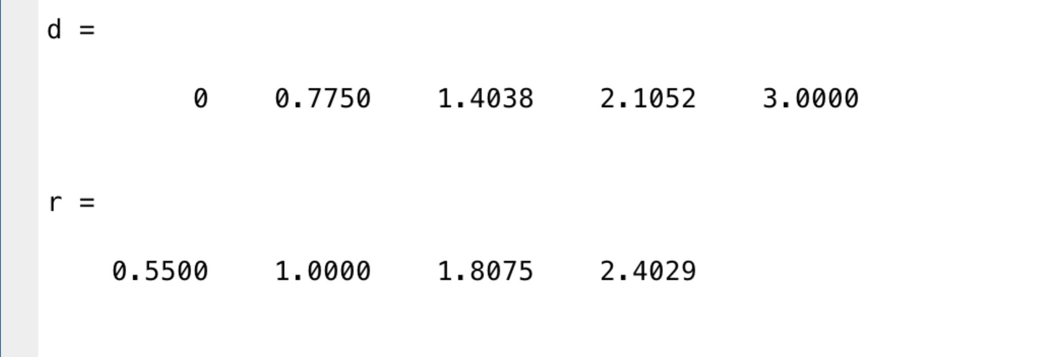

So the result is :

Decision levels:  
d0 = 0, d1 = 0.7750, d2 = 1.4038, d3 = 2.1052, d4 = 3

Reconstruction values:

r0 = 0.55, r1 = 1, r2 = 1.8075, r3 = 2.4029

b)

code is the same with a)

Here is the output:

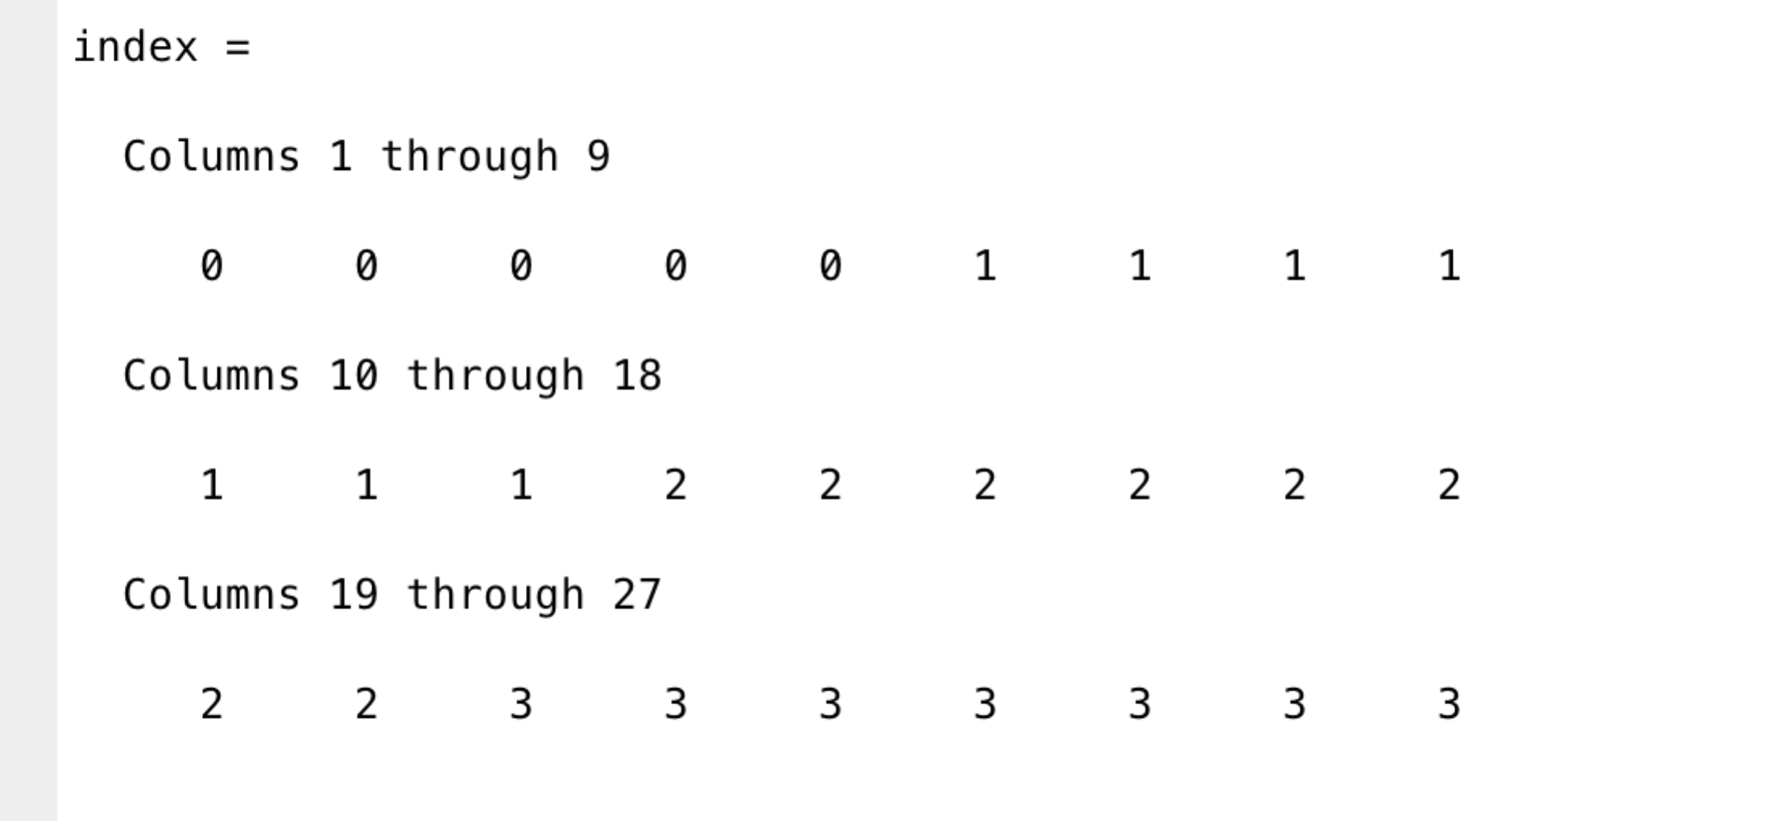

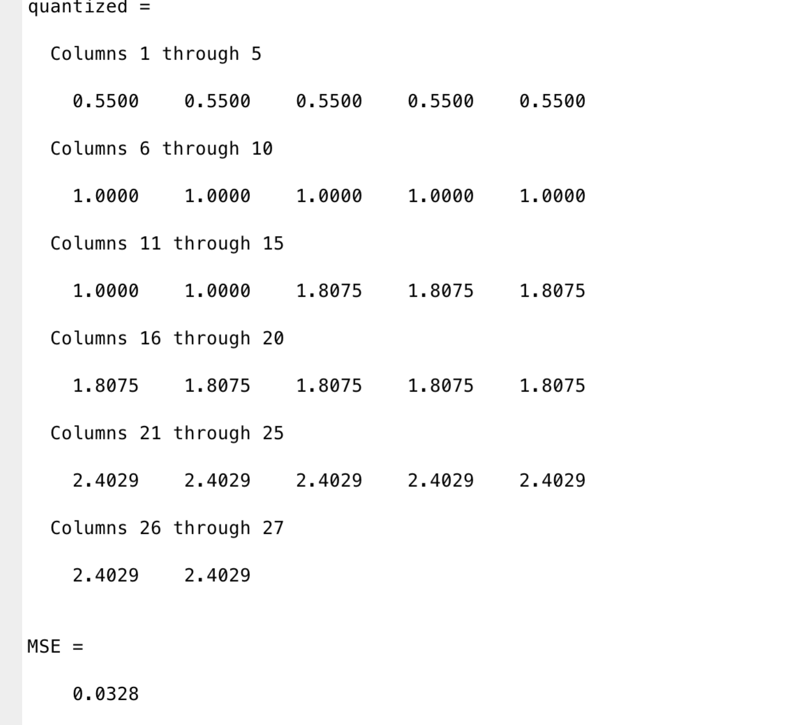

So the quantized array and dequantized values are in the screenshot (index and quantized array)above, the mse is 0.0328

c)

It is 3-level uniform quantizer, so the decision level and reconstruction values are easy to calculate.

The d = [0,1,2,3]

The r = [0.5,1.5,2.5]

Here is the code:

clear

X=[0,0.65, 0.7, 0.7, 0.7, 0.9, 0.9, 1, 1, 1, 1, 1.2, 1.6, 1.8, 1.8, 1.74, 1.75, 1.9, 1.93, 1.94, 2.2,2.2, 2.3, 2.35, 2.37, 2.5, 2.9];

d = [0,1.0,2.0,3]

r = [0.5,1.5,2.5]

index = myquantizer(X,d)

quantized = mydequantizer(index,r)

MSE = mean((quantized-X).^2);

index

quantized

MSE

Here is the output:

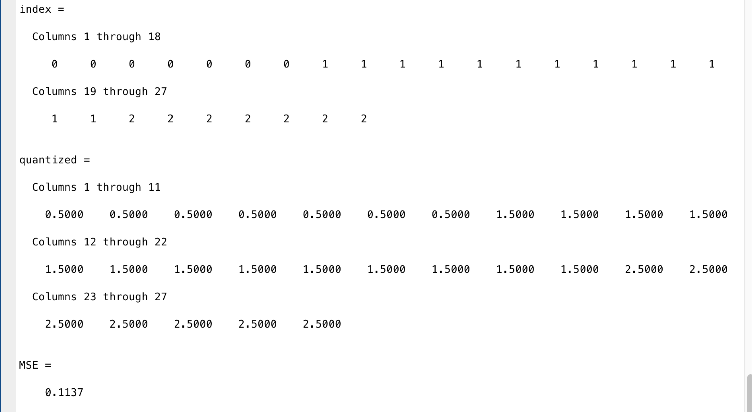

d)

It is a 4-level optimal semi-uniform quantizer so the decision levels are:

d0=0, d1=3/4,d1=6/4,d2=9/4,d3=3

Here is the code:

clear

X=[0,0.65, 0.7, 0.7, 0.7, 0.9, 0.9, 1, 1, 1, 1, 1.2, 1.6, 1.8, 1.8, 1.74, 1.75, 1.9, 1.93, 1.94, 2.2,2.2, 2.3, 2.35, 2.37, 2.5, 2.9];

d = [0,3/4,6/4,9/4,3]

r0array = []

r1array = []

r2array = []

r3array = []

for i = 1:length(X)

if (X(i) < d(2) && X(i) >= d(1))

r0array = [r0array,X(i)]

elseif(X(i)>=d(2) && X(i)<d(3))

r1array = [r1array,X(i)]

elseif (X(i)>=d(3) && X(i)<d(4))

r2array = [r2array,X(i)]

else

r3array = [r3array,X(i)]

end

end

r0 = mean(r0array)

r1 = mean(r1array)

r2 = mean(r2array)

r3 = mean(r3array)

r = [r0,r1,r2,r3]

index = myquantizer(X,d)

quantized = mydequantizer(index,r)

MSE = mean((quantized-X).^2);

index

quantized

MSE

Here is the output:

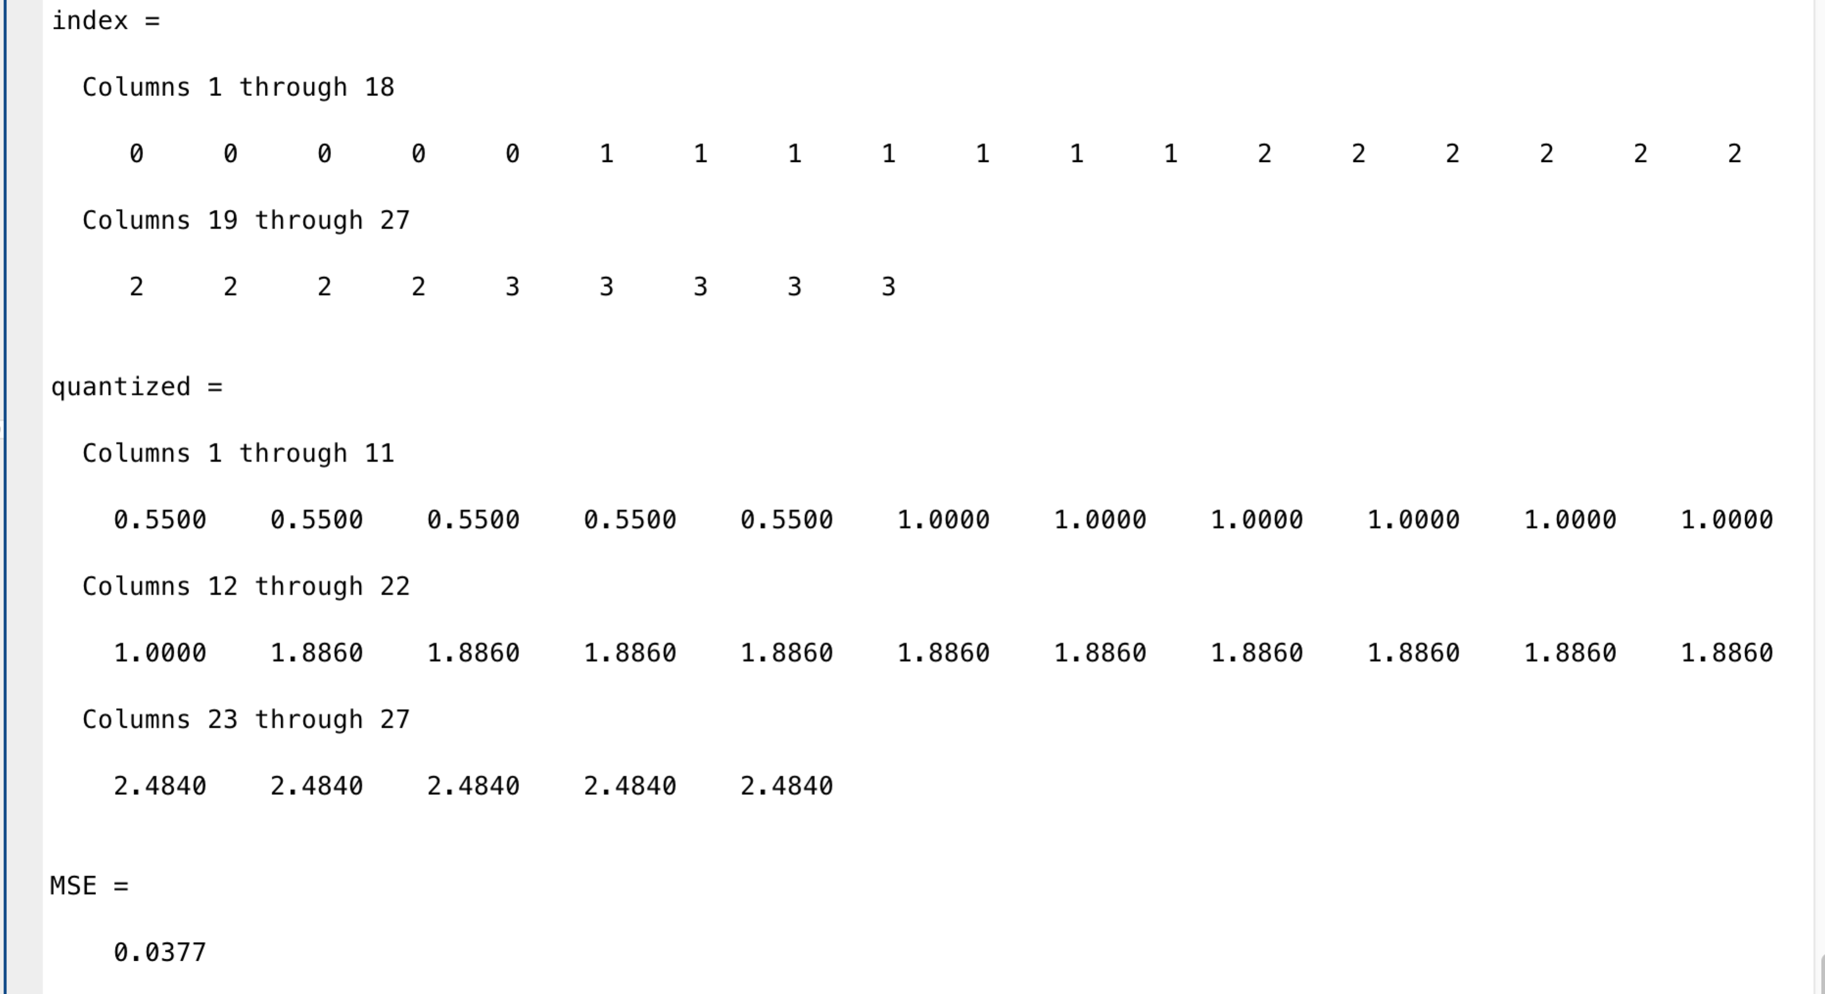

e)

in b) the MSE is 0.0328 while in d) the MSE is 0.0377. So optimal Max-Lloyd is better. (The result is reasonable because b) is the optimal while in d) it is just semi optimal.)

Problem2

Here is the original G picture

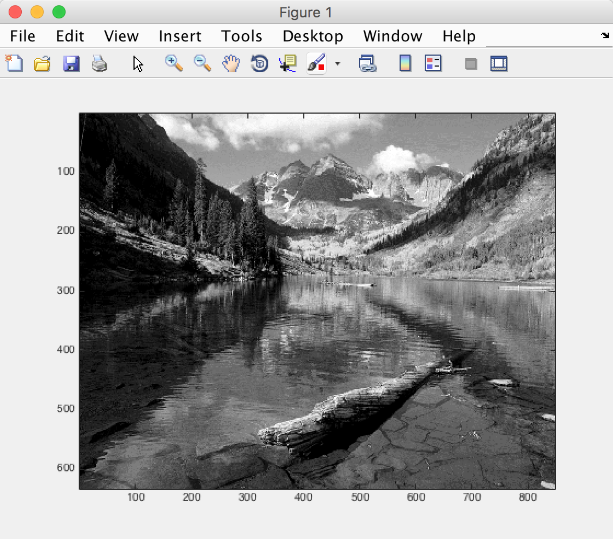

My Answer:

Here is the code to solve the problem:  
clear

[I,map] = imread('River.gif')

G = ind2gray(I,map)

E = entropy(G)

1. 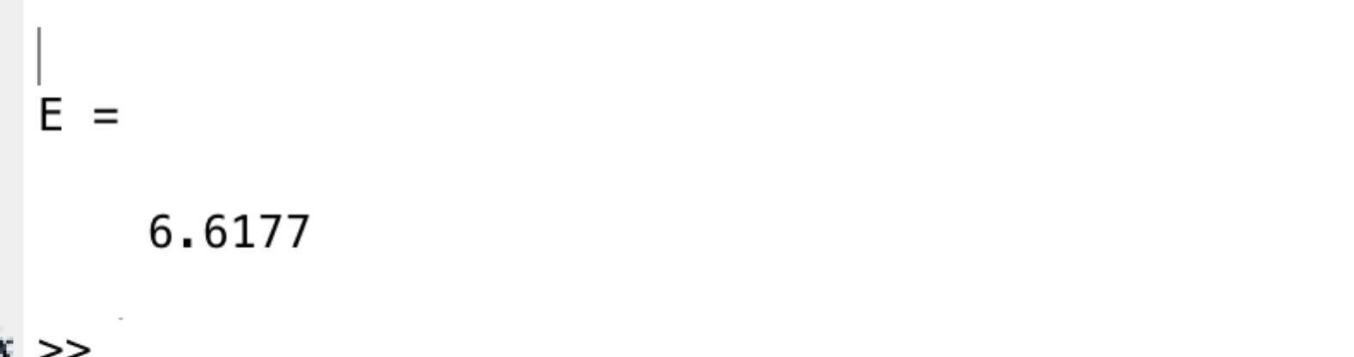

so the entropy is 6.6177

b)

Here is the code:

clear;

[I,map] = imread('River.gif');

G = ind2gray(I,map);

E = entropy(G);

largest = double(max(max(G)));

smallest = double(min(min(G)));

d0 = smallest;

d8 = largest + 0.001;

interval = (d8 - d0)/8;

d = [d0];

for i = 1:7

d = [d,d0 + i \* interval];

end

d = [d,d8]

for i = 1:8

r(i) = ((d(i) + d(i+1))/2);

end

for i = 1:size(G,1)

index(i,:) = myquantizer(G(i,:),d);

end

for i = 1:size(index,1)

quantized(i,:) = mydequantizer(index(i,:),r);

end

r

E1 = entropy(index)

snr = snr(G,quantized)

imagesc(quantized)

colormap(gray)

Notice that we need to transfer the data from double to uint8 so that it can be displayed in the picture.

Here is the output:

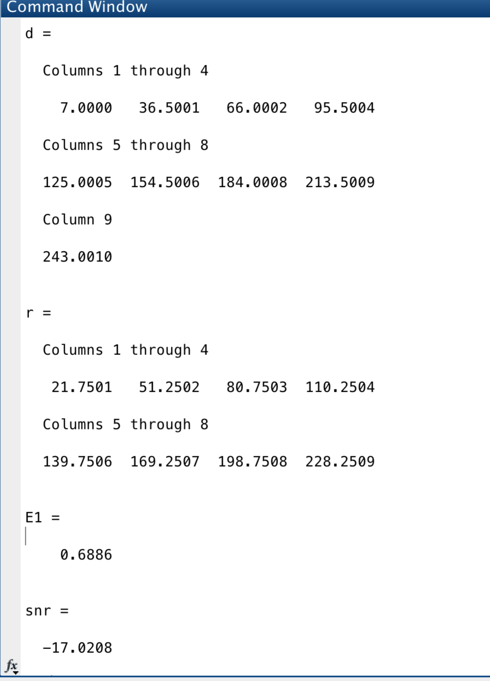

the minimux number is 7 and the max number is 243

we add 0.001 to 243 so d8 = 243.001

so the decision values and reconstruction values are like the screenshot above.

the entropy of G’ is 0.6886

Gu is like the following screenshot, it is a 632\*848 matrix. All the values are in reconstruction values.

SNR(G,Gu) = -17.0208

Here is the Gu, not clear as the original one but looks ok.

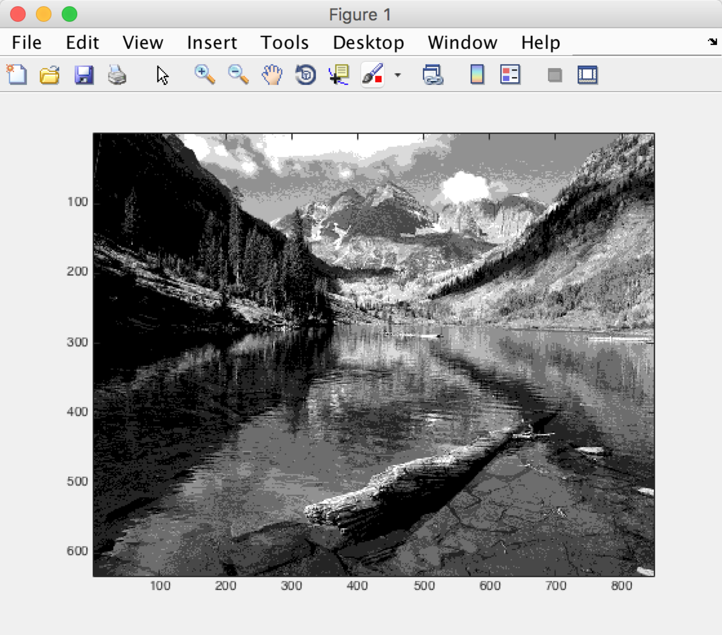

c)8-level semi-uniform quantizer

Here is the code:

clear;

[I,map] = imread('River.gif');

G = ind2gray(I,map);

E = entropy(G);

largest = double(max(max(G)));

smallest = double(min(min(G)));

d0 = smallest;

d8 = largest + 0.001;

interval = (d8 - d0)/8;

d = [d0];

for i = 1:7

d = [d,d0 + i \* interval];

end

d = [d,d8]

r0array = [];

r1array = [];

r2array = [];

r3array = [];

r4array = [];

r5array = [];

r6array = [];

r7array = [];

r = [];

for i = 1:size(G,1)

index(i,:) = myquantizer(G(i,:),d);

end

for i = 1:size(index,1)

for j = 1:size(index,2)

if(index(i,j) == 0)

r0array = [r0array,G(i,j)];

elseif (index(i,j) == 1)

r1array = [r1array,G(i,j)];

elseif (index(i,j) == 2)

r2array = [r2array,G(i,j)];

elseif (index(i,j) == 3)

r3array = [r3array,G(i,j)];

elseif (index(i,j) == 4)

r4array = [r4array,G(i,j)];

elseif (index(i,j) == 5)

r5array = [r5array,G(i,j)];

elseif (index(i,j) == 6)

r6array = [r6array,G(i,j)];

elseif (index(i,j) == 7)

r7array = [r7array,G(i,j)];

end

end

end

r(1) = (mean(r0array));

r(2) = (mean(r1array));

r(3) = (mean(r2array));

r(4) = (mean(r3array));

r(5) = (mean(r4array));

r(6) = (mean(r5array));

r(7) = (mean(r6array));

r(8) = (mean(r7array));

r = (r);

for i = 1:size(index,1)

quantized(i,:) = mydequantizer(index(i,:),r);

end

r

E1 = entropy(index)

snr = snr(G,quantized)

imagesc(quantized)

colormap(gray)

Here is the output:

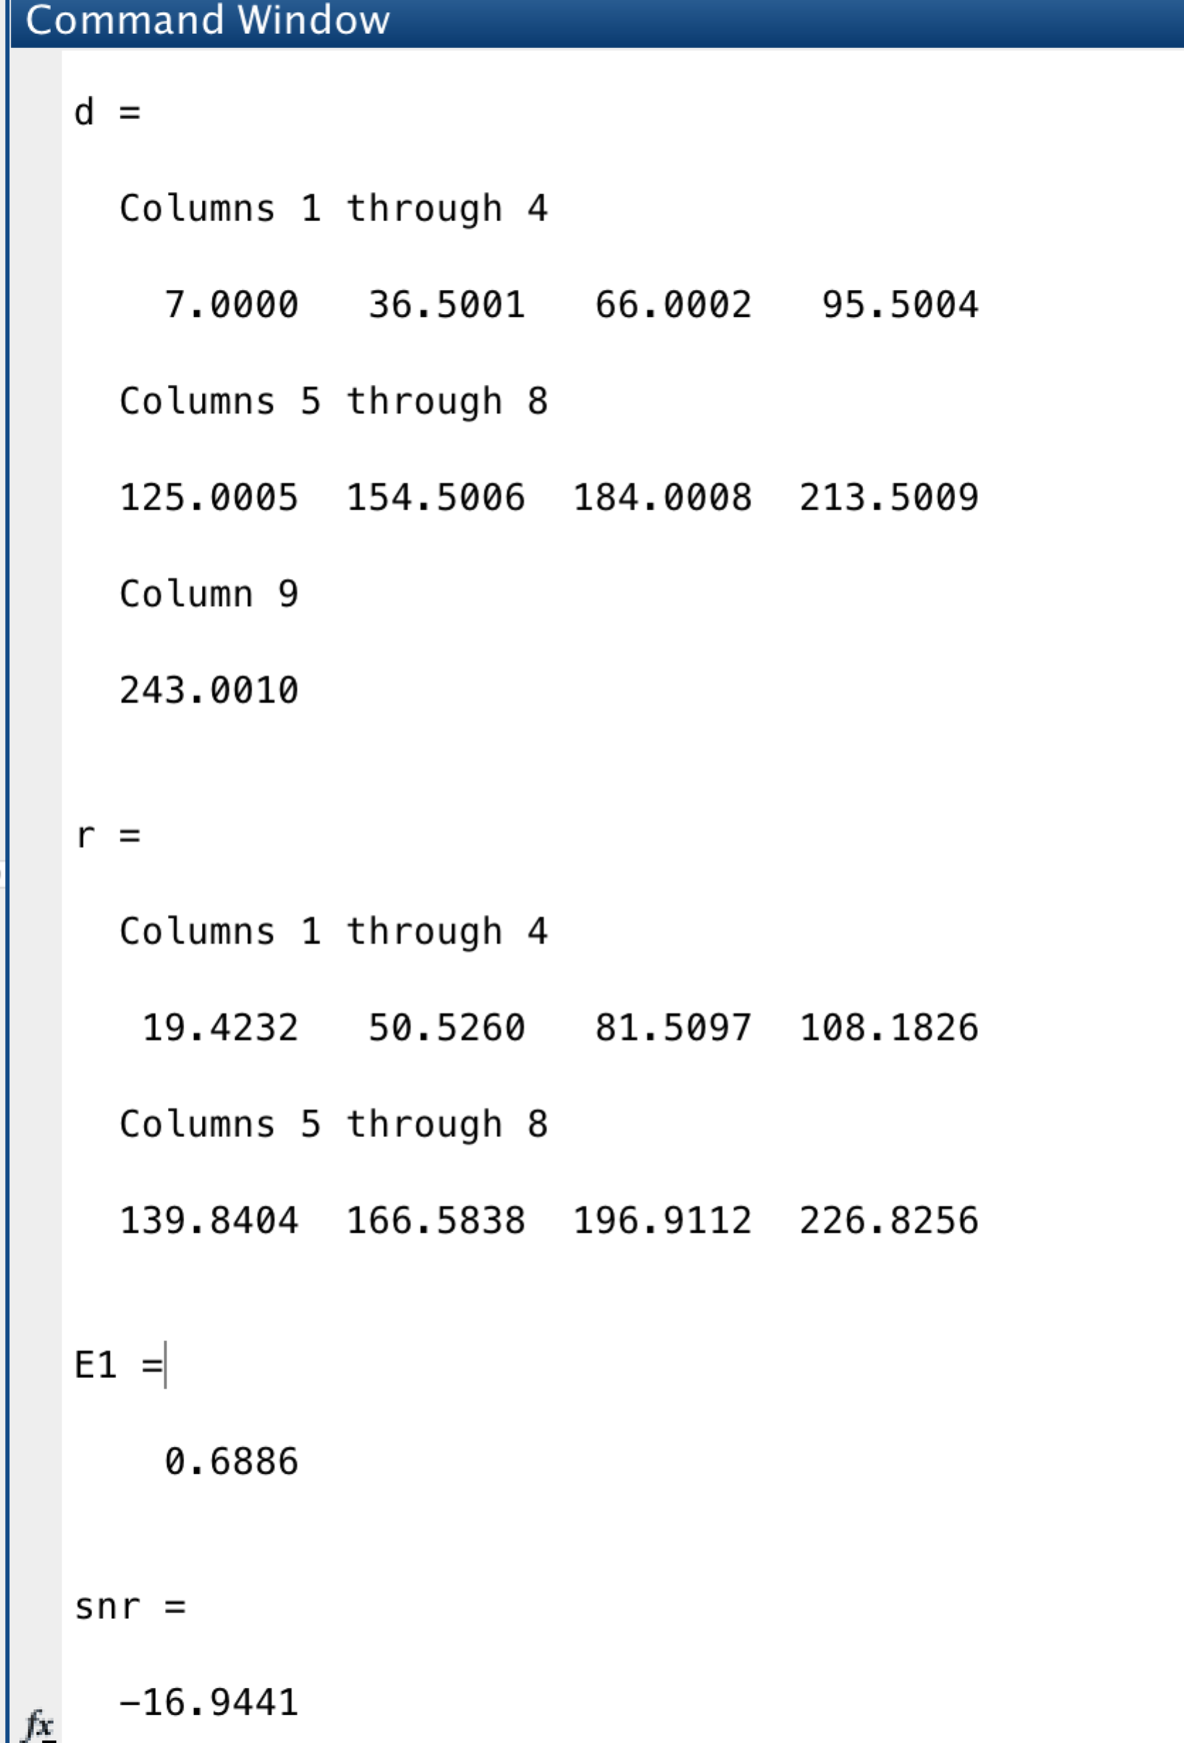

the SNR is -16.9441

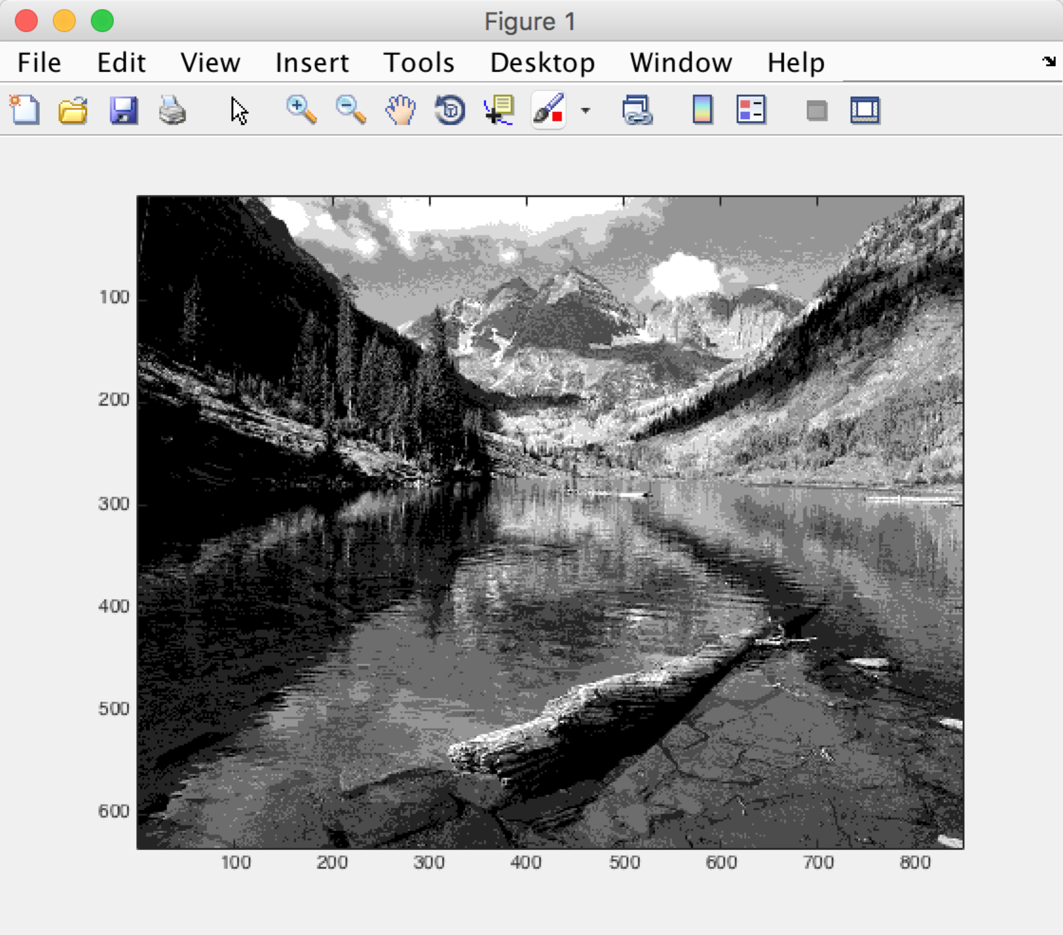

d)

Here is the code:  
clear;

[I,map] = imread('River.gif');

G = ind2gray(I,map);

E = entropy(G);

largest = double(max(max(G)));

smallest = double(min(min(G)));

myvec = double(reshape(G,1,[]));

[d,r] = lloyds(myvec,8);

d = [smallest,d,largest+0.001];

r = (r);

for i = 1:size(G,1)

index(i,:) = myquantizer(G(i,:),d);

end

for i = 1:size(index,1)

quantized(i,:) = mydequantizer(index(i,:),r);

end

d

r

E1 = entropy(index)

snr = snr(G,quantized)

imagesc(quantized)

colormap(gray);

Here is the output:

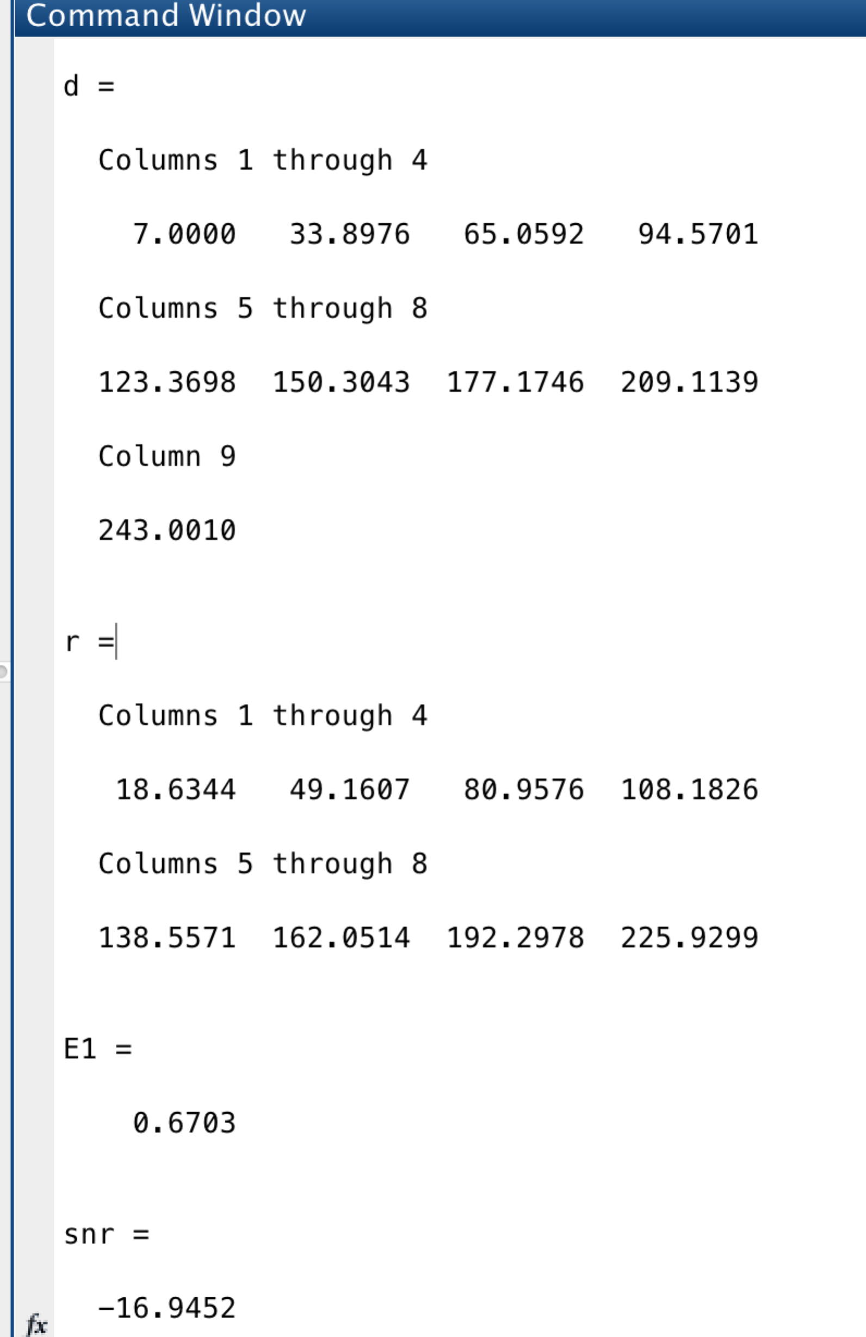

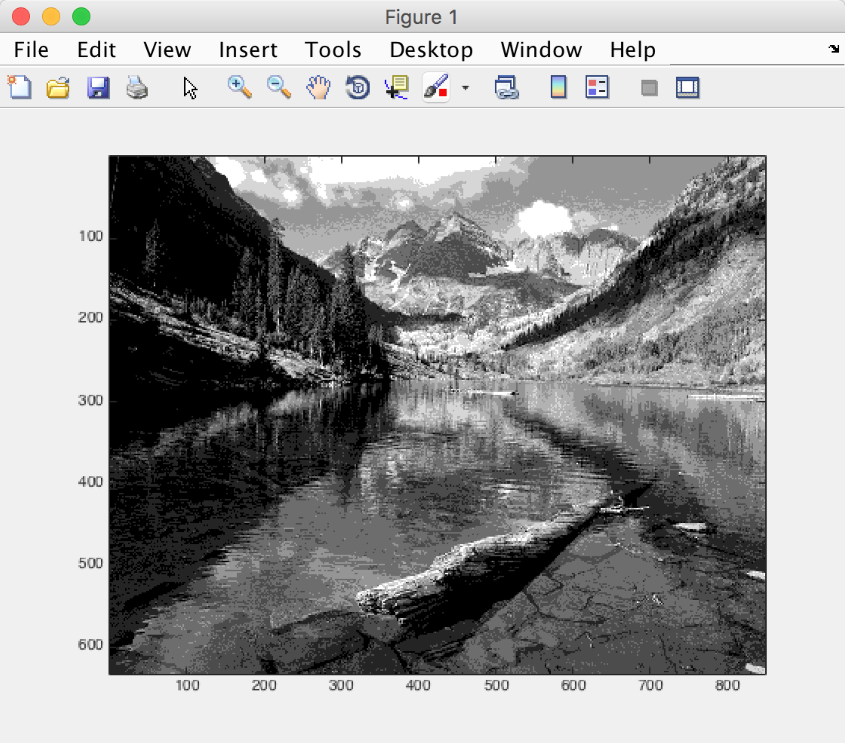

e)

The entropy of b,c are the same but d has the smallest entropy. The SNR of the three ways are not different much. Visually I think the three reconstructed picture got similar effect…maybe d is better because it is optimal quantizer.

Problem3

MyDPCM function code:

function [R] = MyDPCM(G,a,b,c )

% initial

R(1,1) = G(1,1);

% first row

for j = 2:size(G,2)

R(1,j) = G(1,j) - G(1,j-1);

end

% first column

for i = 2:size(G,1)

R(i,1) = G(i,1) - G(i-1,1);

end

for i = 2:size(G,1)

for j = 2:size(G,2)

R(i,j) = floor(G(i,j)-(a\*G(i,j-1)+b\*G(i-1,j-1)+c\*G(i-1,j)));

end

end

end

My Answer:

ab)

Here is the code:

clear;

[I,map] = imread('River.gif');

G = ind2gray(I,map);

a1 = 1;

b1 = 0;

c1 = 0;

a2 = 0;

b2 = 0;

c2 = 1;

a3 = 0.5;

b3 = 0;

c3 = 0.5;

a4 = 1.0;

b4 = -1.0;

c4 = 1.0;

a5 = 0.75;

b5= -0.5;

c5 = 0.75;

R1 = (MyDPCM(G,a1,b1,c1));

R2 = (MyDPCM(G,a2,b2,c2));

R3 = (MyDPCM(G,a3,b3,c3));

R4 = (MyDPCM(G,a4,b4,c4));

R5 = (MyDPCM(G,a5,b5,c5));

E1 = entropy(R1)

E2 = entropy(R2)

E3 = entropy(R3)

E4 = entropy(R4)

E5 = entropy(R5)

minE = min([E1,E2,E3,E4,E5])

% imagesc(R1);

% colormap(gray);

largest = double(max(max(R1)))

smallest = double(min(min(R1)))

myvec = double(reshape(R1,1,[]));

[d,r] = lloyds(myvec,8);

d = [smallest,d,largest+0.001];

for i = 1:size(R1,1)

index(i,:) = myquantizer(R1(i,:),d);

end

Eprime = reshape(index',1,[]);%make sure it is rowwise, we need transpose index

% need to do runlength////////////////

[numbers,times] = MyRLE(Eprime);

rle = [];

rle = [times,numbers];

e = entropy(rle)

for i = 1:size(index,1)

quantized(i,:) = mydequantizer(index(i,:),r);

end

ReG = MyReconstruction(quantized,a1,b1,c1);

imagesc(ReG);

colormap(gray);

Here is the output:

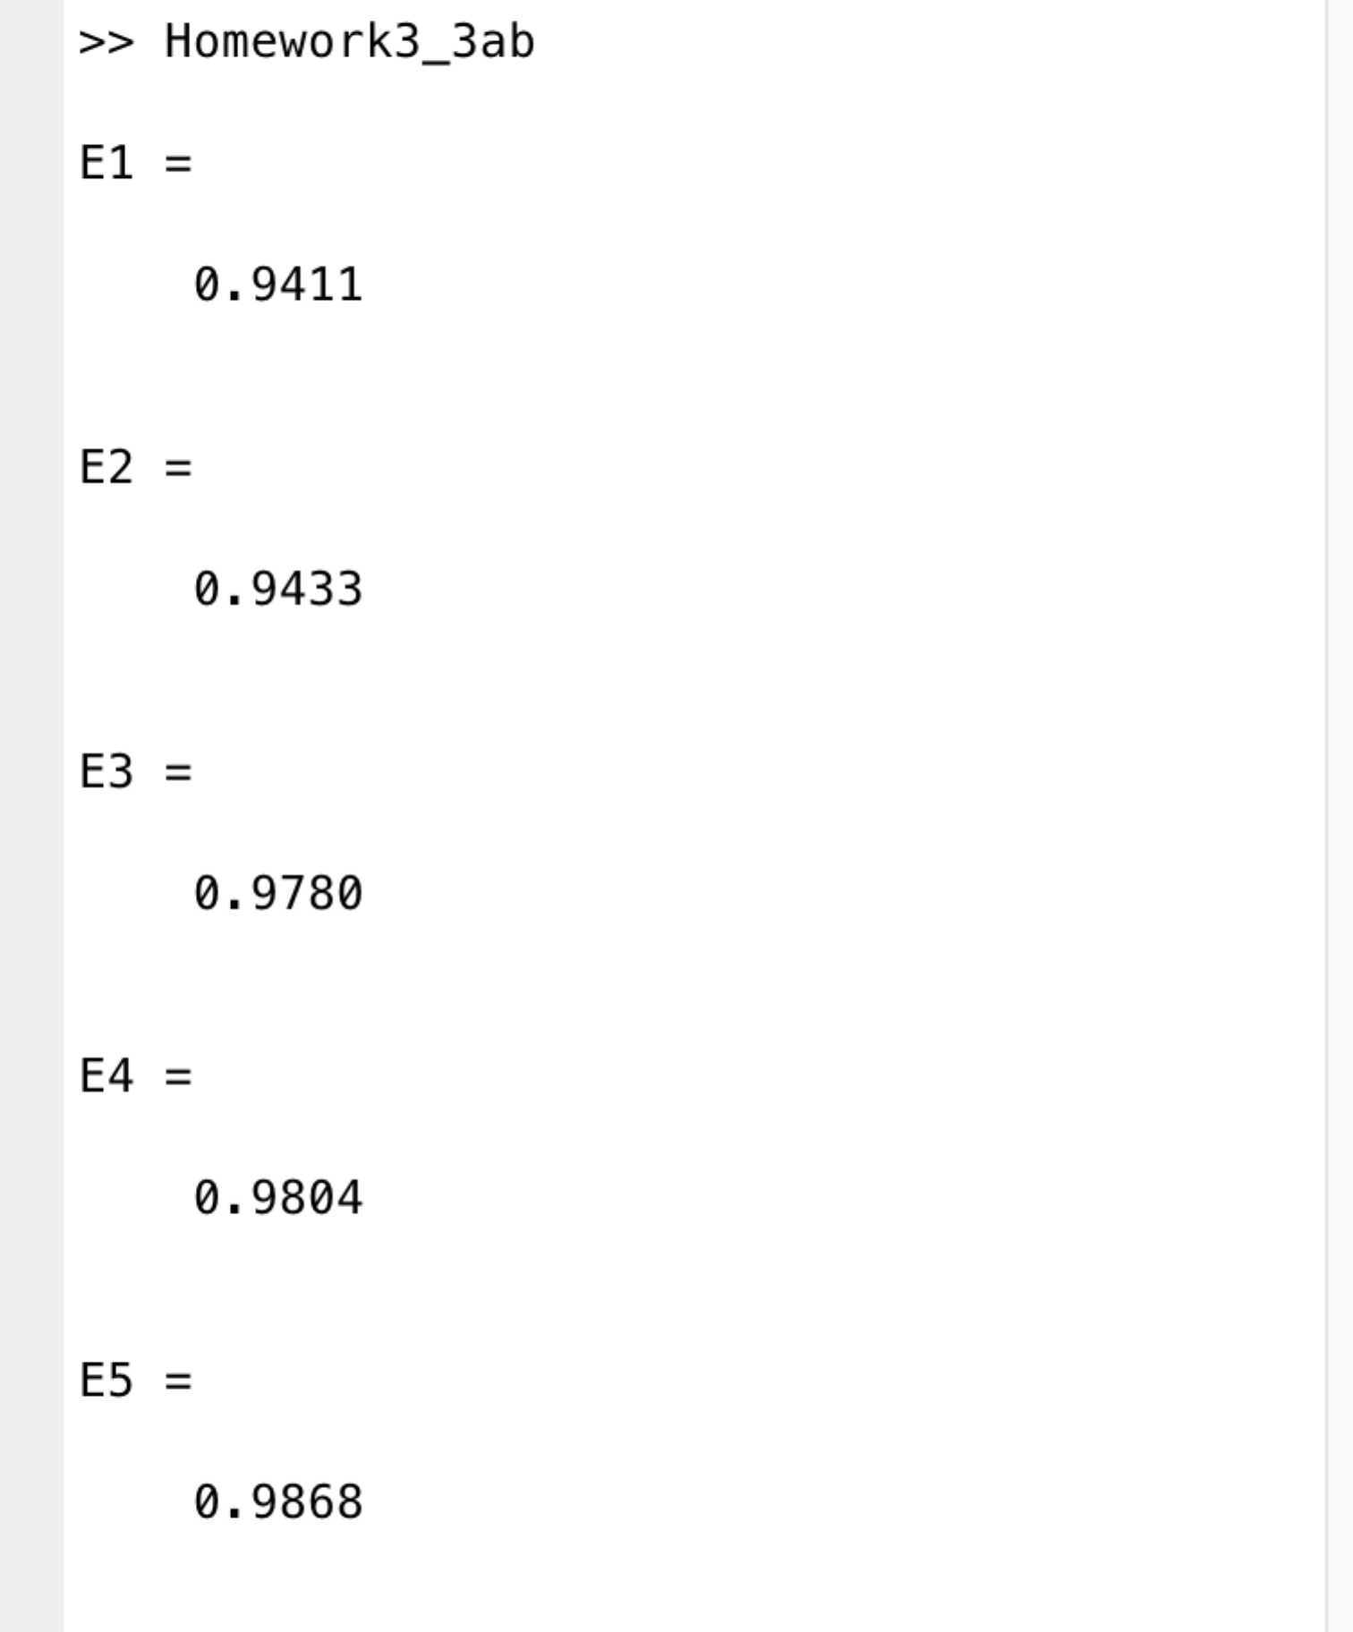

So E1 is the minimum, so we display R1

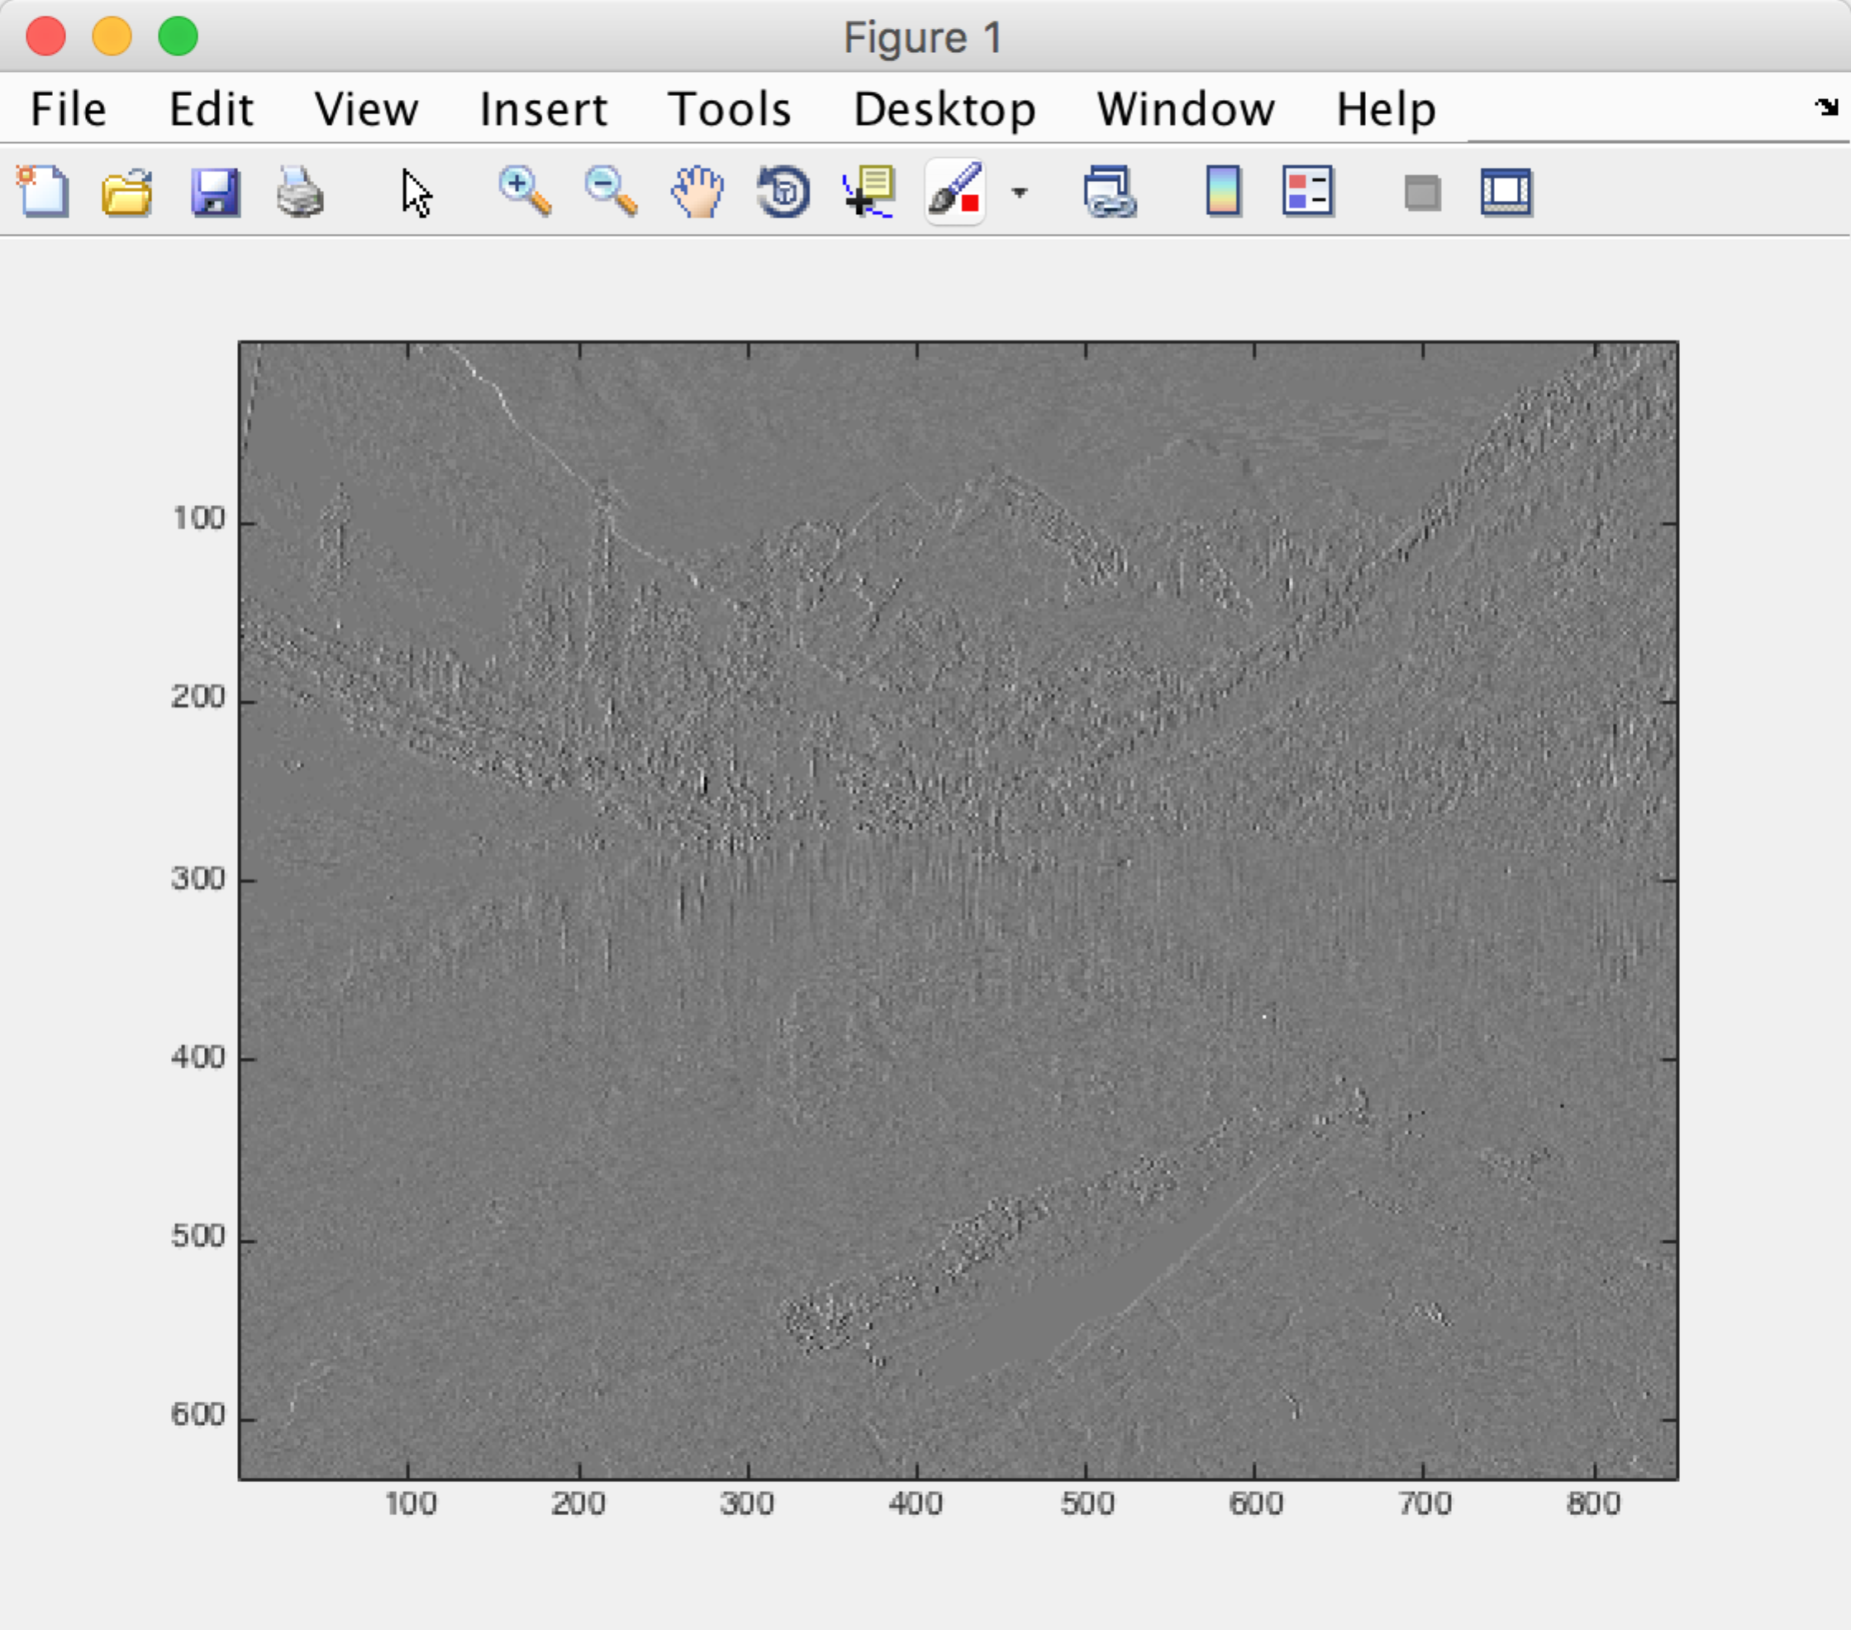

c)

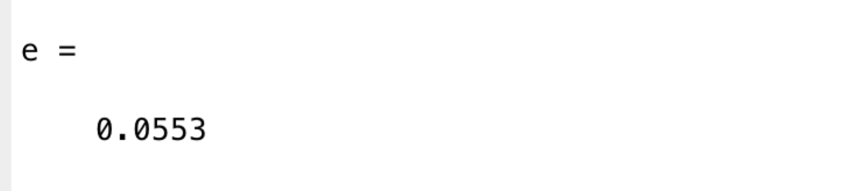

d)

we get the picture of 8-level:

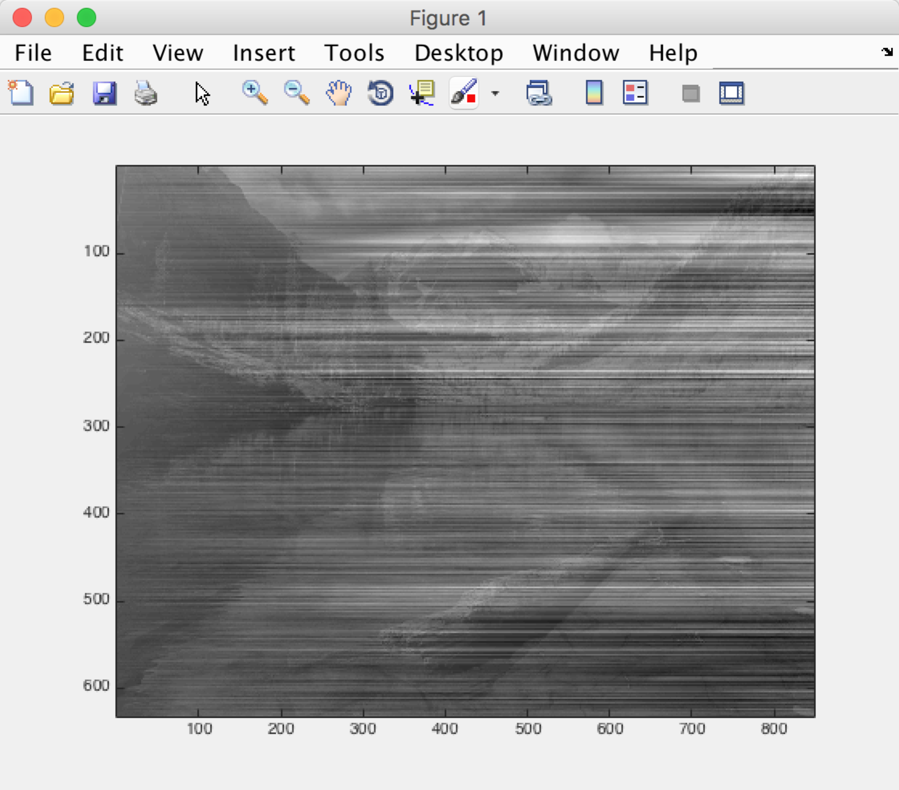

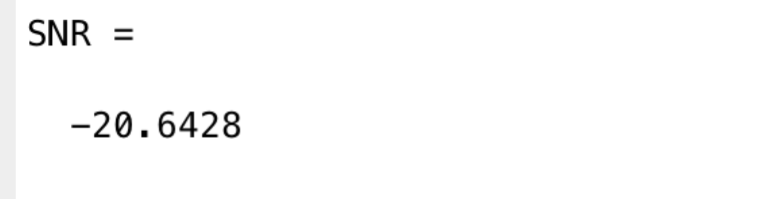

if we change the level to maybe 128 , we will get :

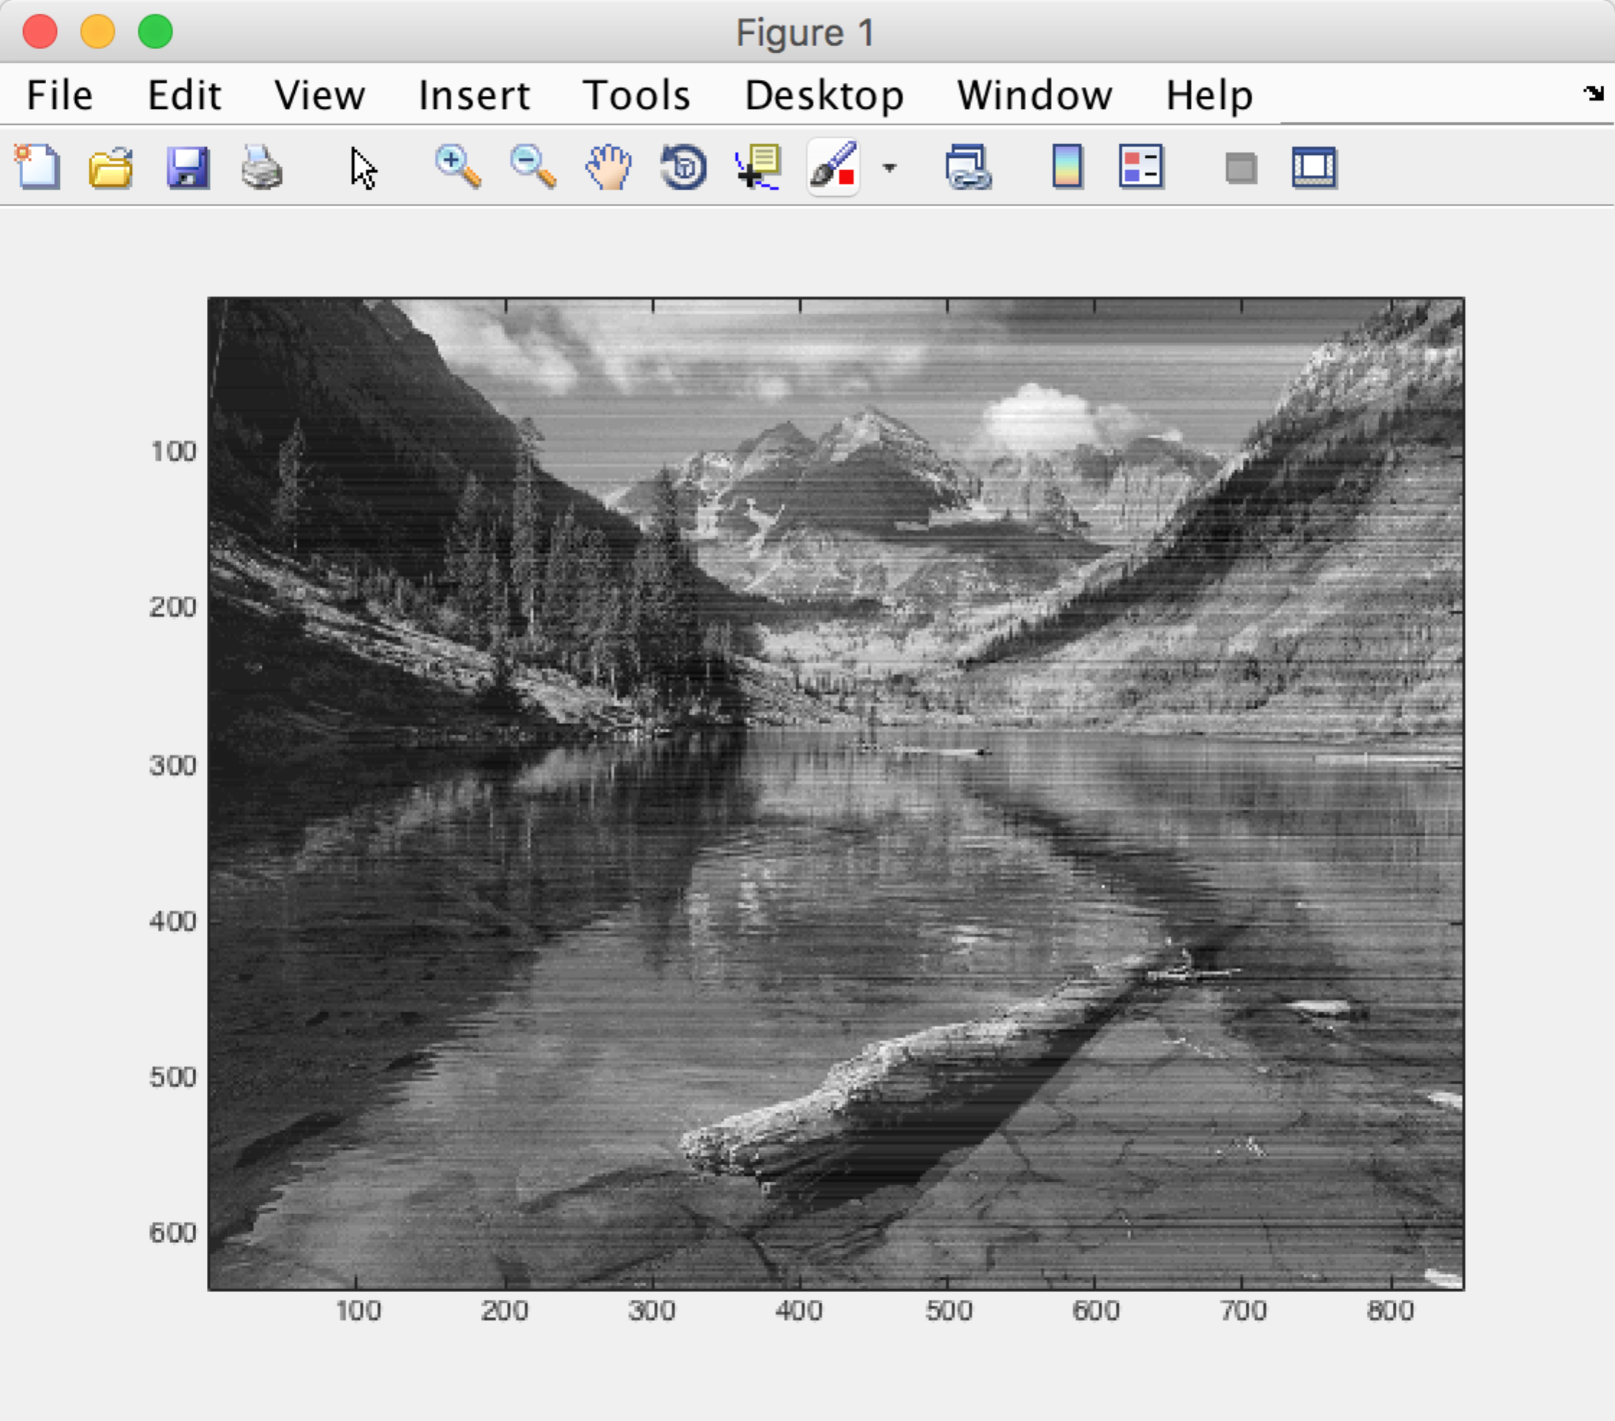

it is more clear.

e)

The visual quality is really bad. I think it is because we use 8-level Max-Lloyds to quantize. 8 levels are not enough because the range is from -172 to 186. And the errors will become larger and larger(Because the next pixel relies on the values of its previous one, if the previous one is not accuracy, the next one may be worse. In addition, since we choose a = 1,b=0,c=0, so it appears to be like scanned by line).

I also tried the rest condition of a,b,c and we get(I use 128 levels so it is more clear):

(0,0,1)

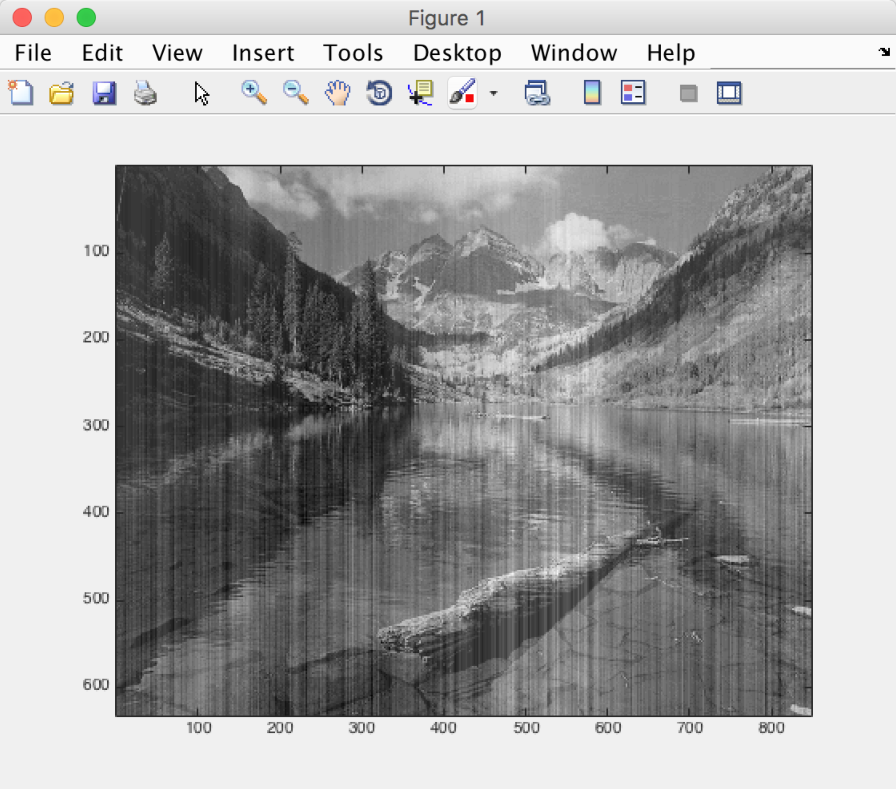

(0.5,0,0.5) this one looks great.

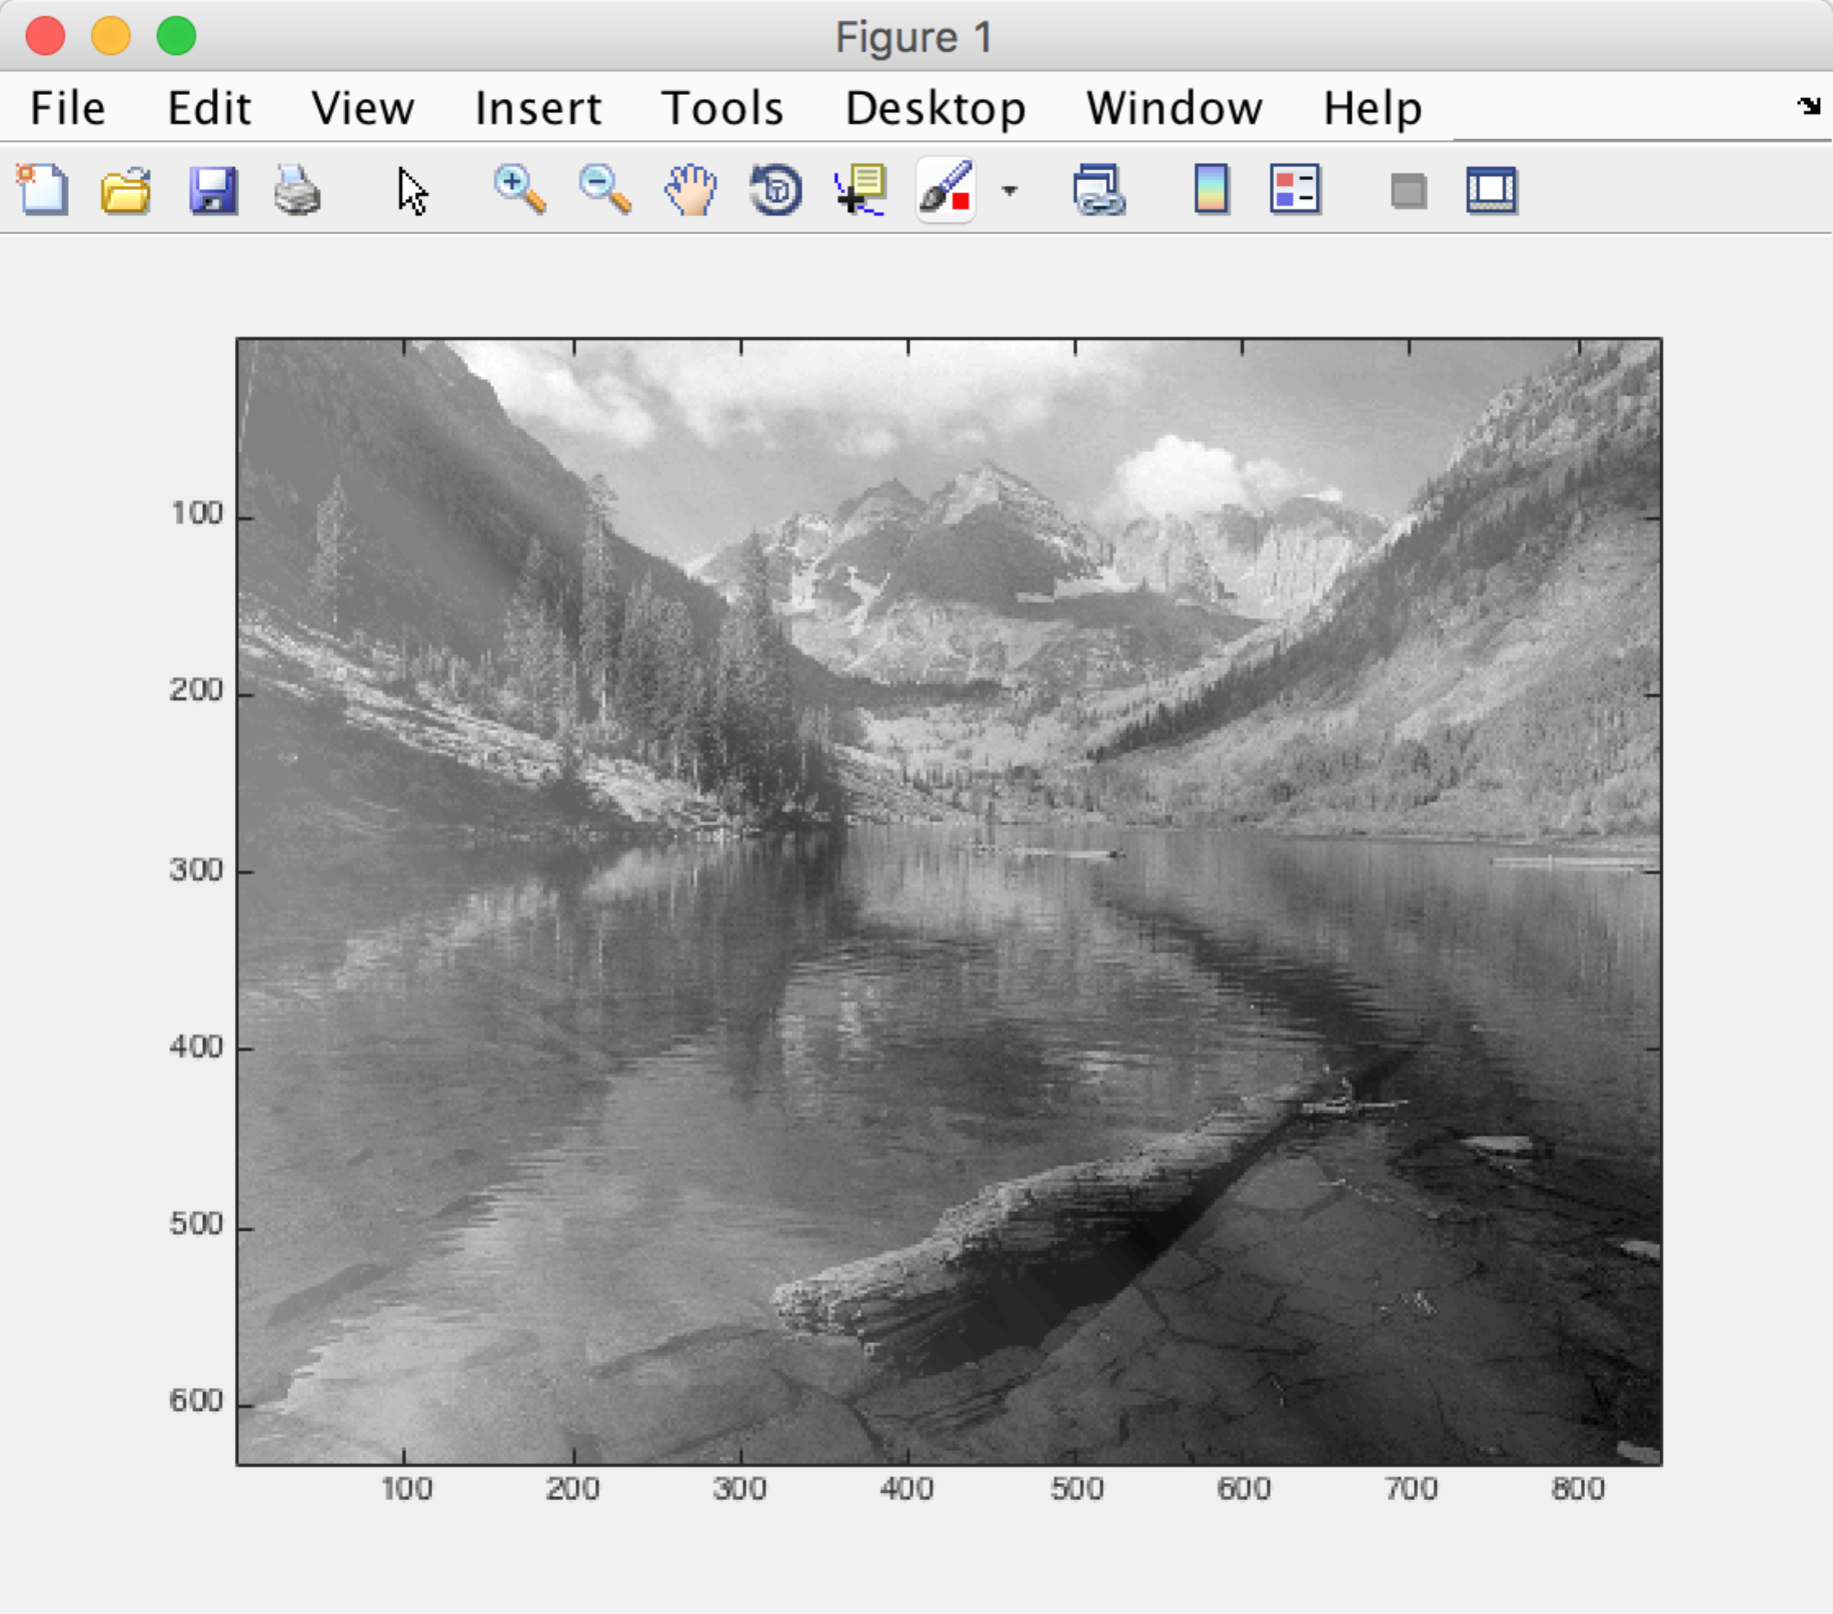

(1,-1,1) ???? why is that. Not even close

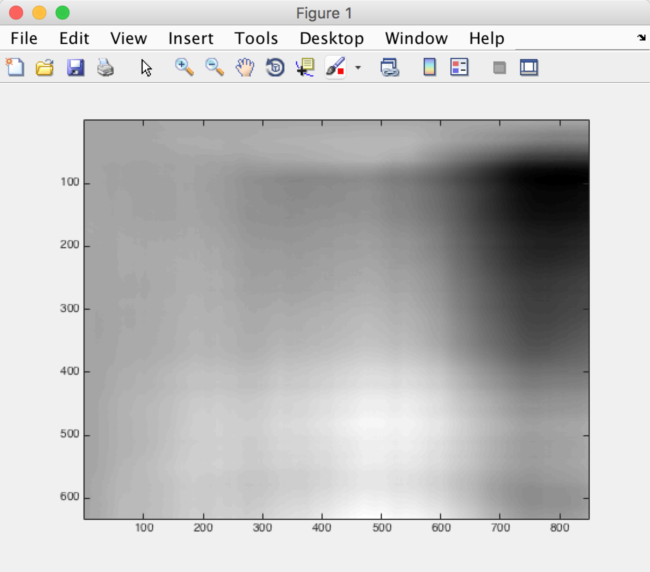

(0.75,-0.5,0.75) looks ok but too much white

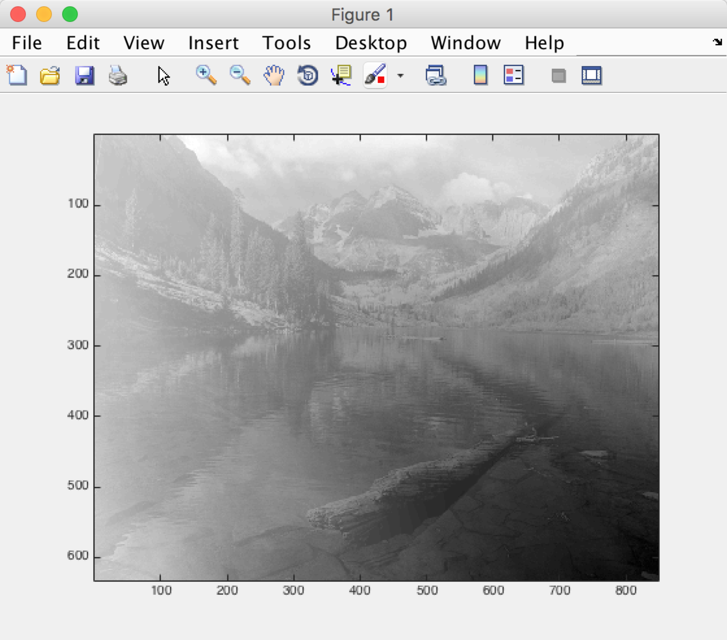

Problem4

My Answer:

1. First we could think in that way:

For each 8\*8 block, we only need to keep the one DC term and 9 AC term, totally 10 elements need to keep.

So the bitrate is 10/64, the compression ratio is 6.4.

Because we use 64-level quantizer for DCterm and 8-level quantizer for AC term, so 6 bit for DC term and 3 bit AC term. So we could calculate it more specific.

Bitrate = (8374\*6+8374\*9\*3)/(632\*848\*8) = 0.0645

Compression ration = 1/0.0645 = 15.5152

b)

here is the code:

clear;

[I,map] = imread('River.gif');

G = ind2gray(I,map);

rownum = size(G,1);

colnum = size(G,2);

pararow = [];

paracol = [];

for i = 1 : rownum/8

pararow = [pararow,8];

end

for i = 1 : colnum/8

paracol = [paracol,8];

end

%divide it to 79\*106 cell

C = mat2cell(G,pararow,paracol);

for i = 1 : size(C,1)

for j = 1 : size(C,2)

D{i,j} = dct2(C{i,j});

end

end

DCterm = [];

% processing DC

for i = 1 : size(C,1)

for j = 1 : size(C,2)

DCterm = [DCterm,D{i,j}(1,1)];

end

end

% [hehe,pad] = vec2mat(DCterm,106);

largest = max(DCterm)

smallest = min(DCterm)

d0 = smallest;

d64 = largest + 0.001;

interval = (d64 - d0)/64;

d = [d0];

r = [];

for i = 1:63

d = [d,d0 + i\*interval];

end

d = [d,d64];

for i = 1:64

r(i) = ((d(i) + d(i+1))/2);

end

DCindex = myquantizer(DCterm,d);

DCquantized = mydequantizer(DCindex,r);

[quantizeddc,pad] = vec2mat(DCquantized,106);

for i = 1 : size(C,1)

for j = 1 : size(C,2)

E{i,j} = zeros(8);

end

end

for i = 1 : size(C,1)

for j = 1 : size(C,2)

E{i,j}(1,1) = quantizeddc(i,j);

end

end

% processing 9 AC term

ACterm = [];

for i = 1 : size(C,1)

for j = 1:size(C,2)

ACterm = [D{i,j}(2,1),D{i,j}(1,2),D{i,j}(3,1),D{i,j}(2,2),D{i,j}(1,3),D{i,j}(4,1),D{i,j}(3,2),D{i,j}(2,3),D{i,j}(1,4)];

largest = max(ACterm);

smallest = min(ACterm);

d0 = smallest;

d8 = largest + 0.001;

interval = (d8 - d0)/8;

d = [d0];

r = [];

for m = 1:7

d = [d,d0+m\*interval];

end

d = [d,d8];

for m = 1:8

r(m) = (d(m) + d(m+1))/2;

end

ACindex = myquantizer(ACterm,d);

ACquantized = mydequantizer(ACindex,r);

%resign back

E{i,j}(2,1) = ACquantized(1);

E{i,j}(1,2) = ACquantized(2);

E{i,j}(3,1) = ACquantized(3);

E{i,j}(2,2) = ACquantized(4);

E{i,j}(1,3) = ACquantized(5);

E{i,j}(4,1) = ACquantized(6);

E{i,j}(3,2) = ACquantized(7);

E{i,j}(2,3) = ACquantized(8);

E{i,j}(1,4) = ACquantized(9);

end

end

for i = 1 : size(E,1)

for j = 1 : size(E,2)

F{i,j} = idct2(E{i,j});

end

end

G10 = cell2mat(F);

imagesc(G10)

colormap(gray);

SNR = snr(G,G10)

Reconstructed image looks pretty good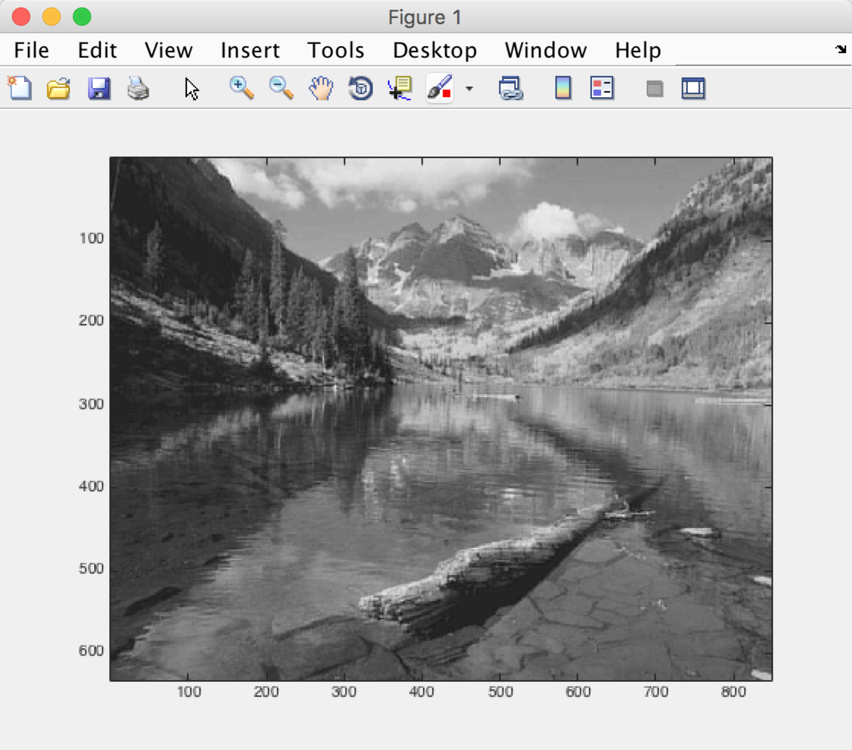

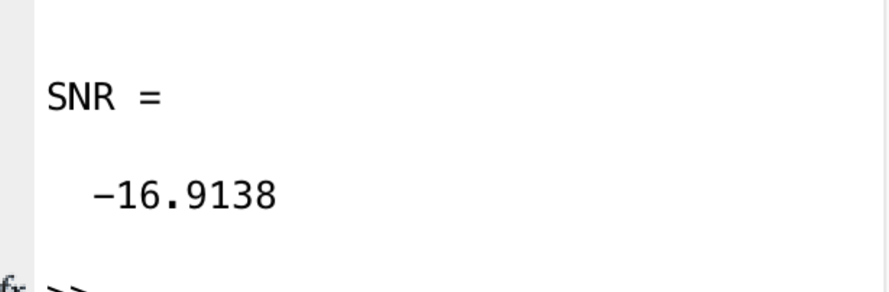

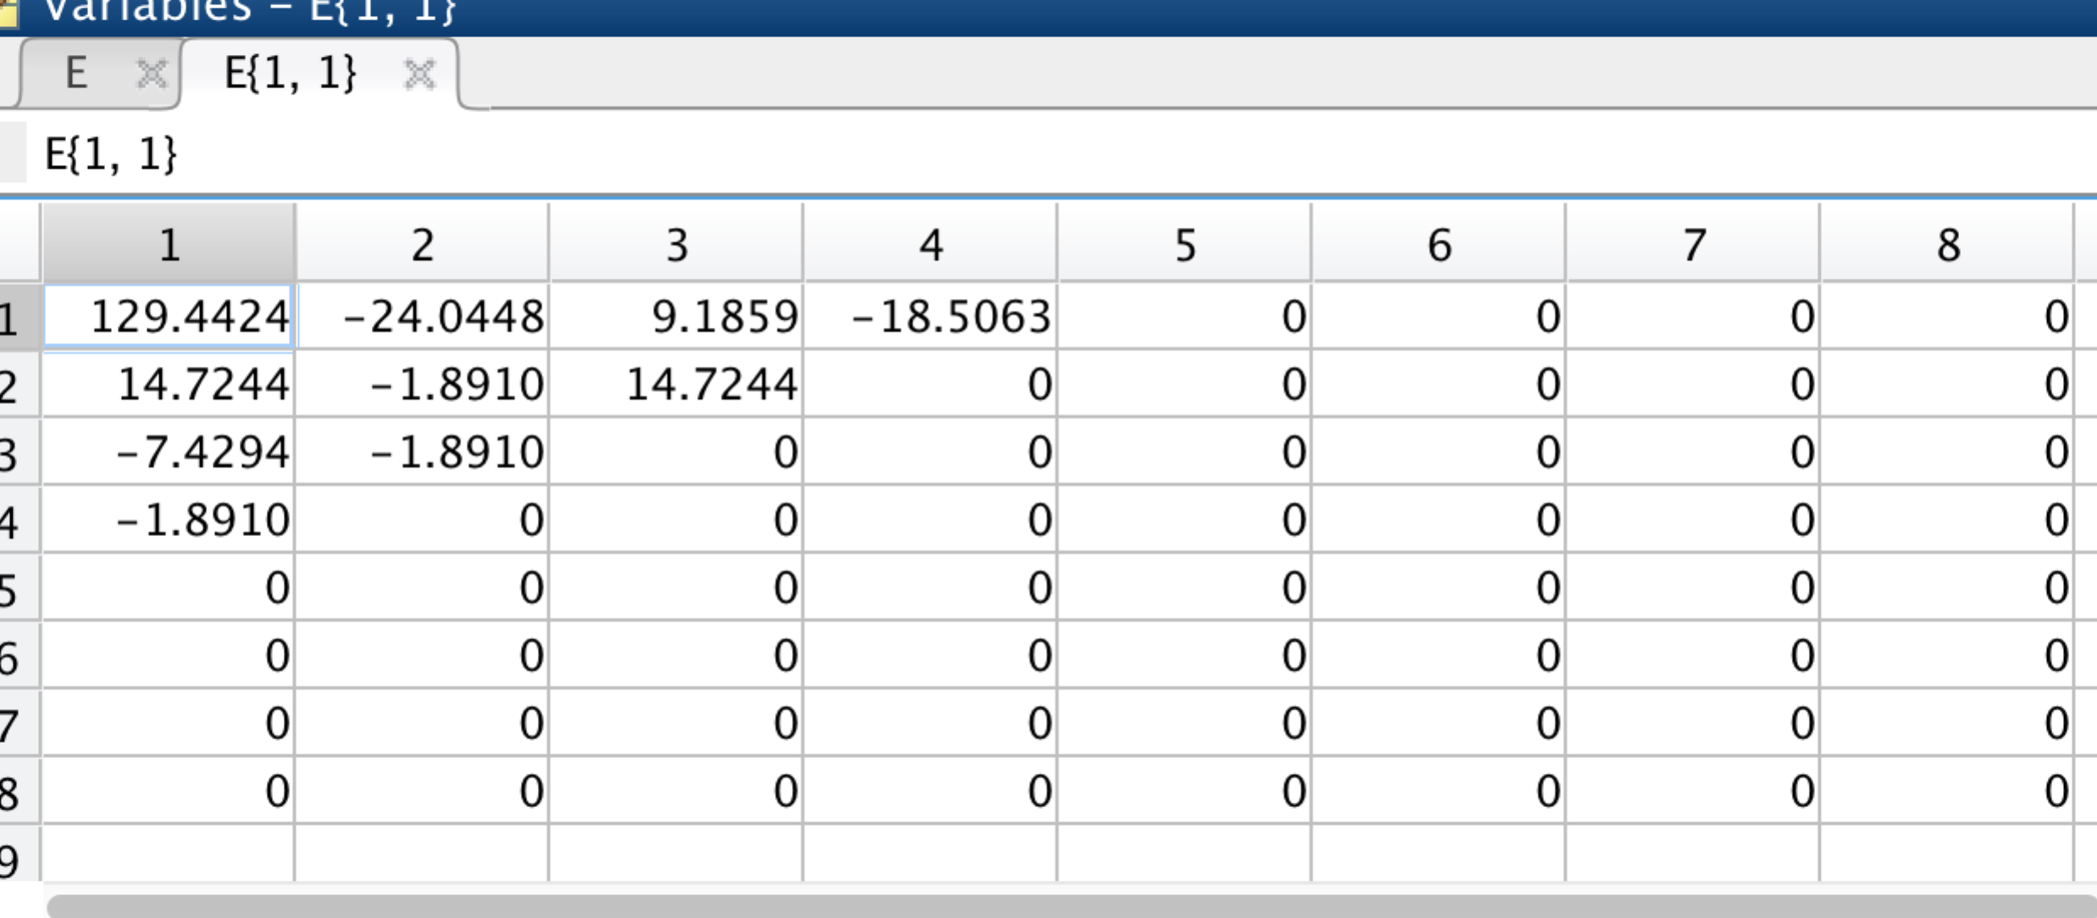

c)

code are similar except drop the 4th counterdiagonals. So I don’t attach the long code here. I will submit all the code alone my submission.

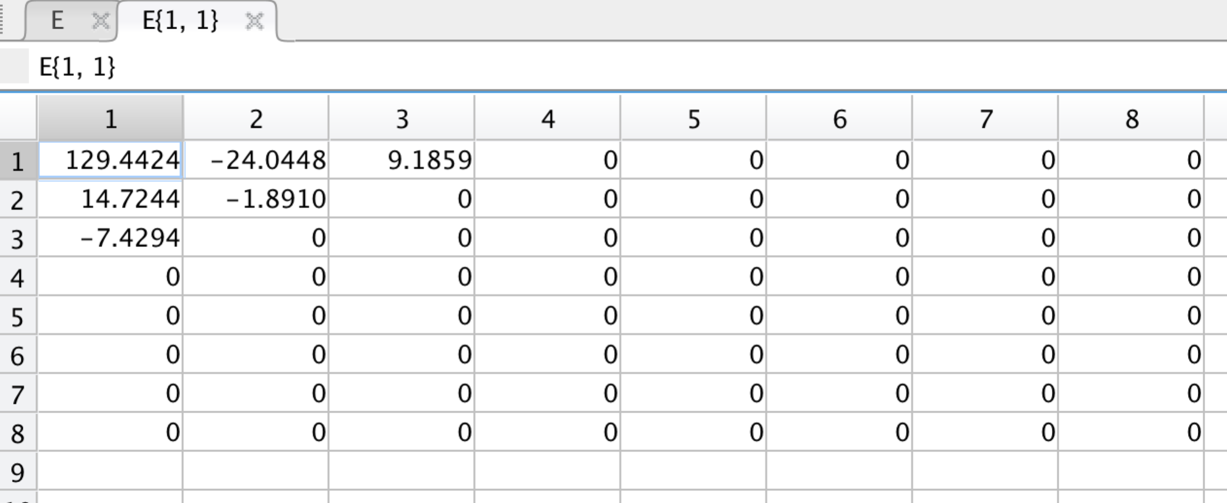

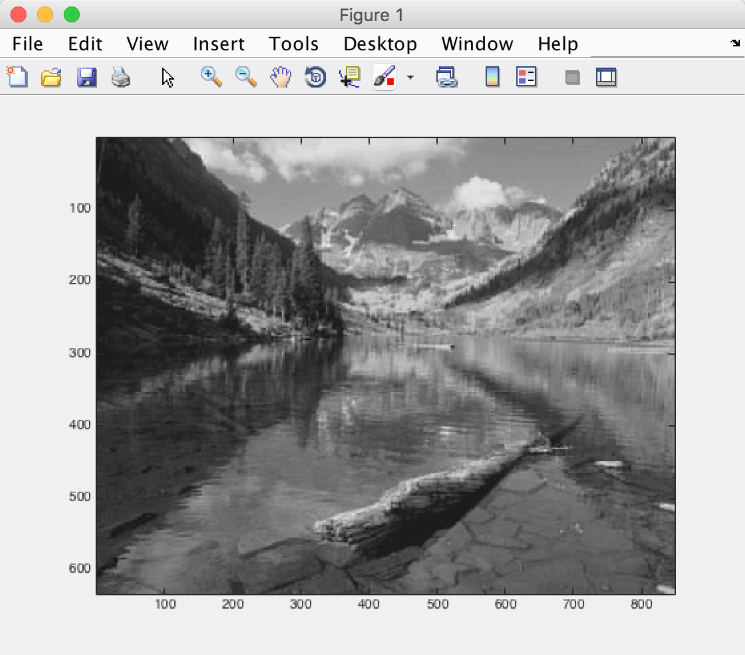

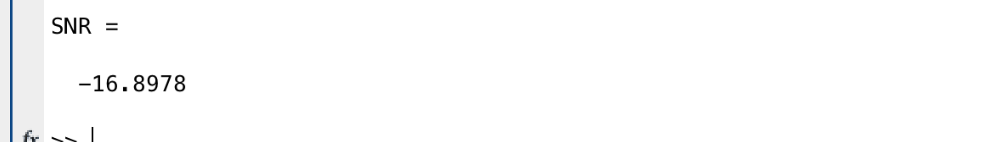

d)

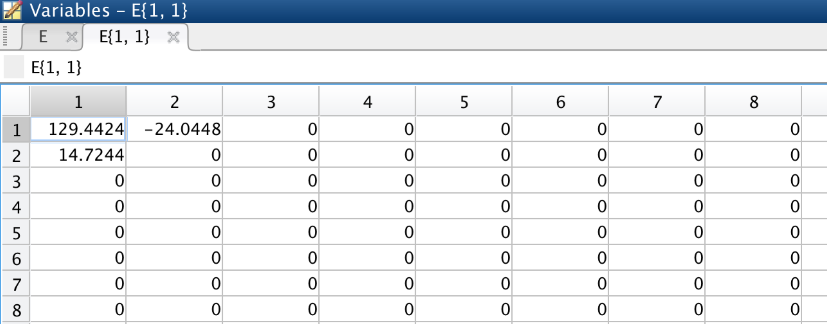

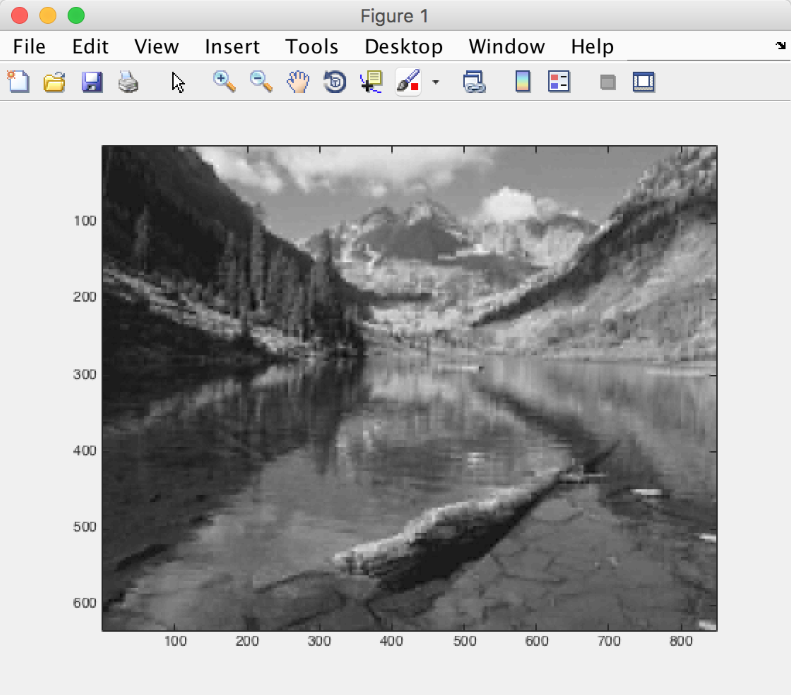

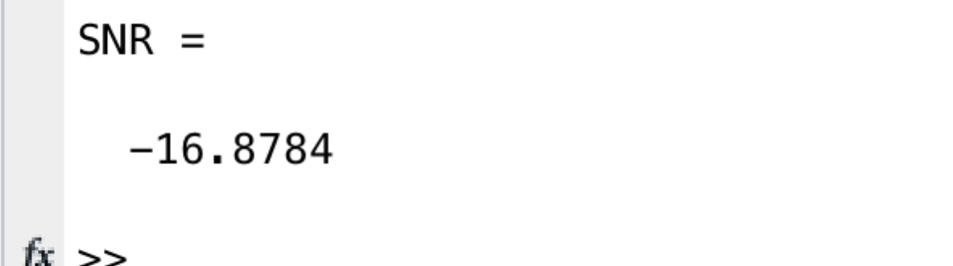

e)

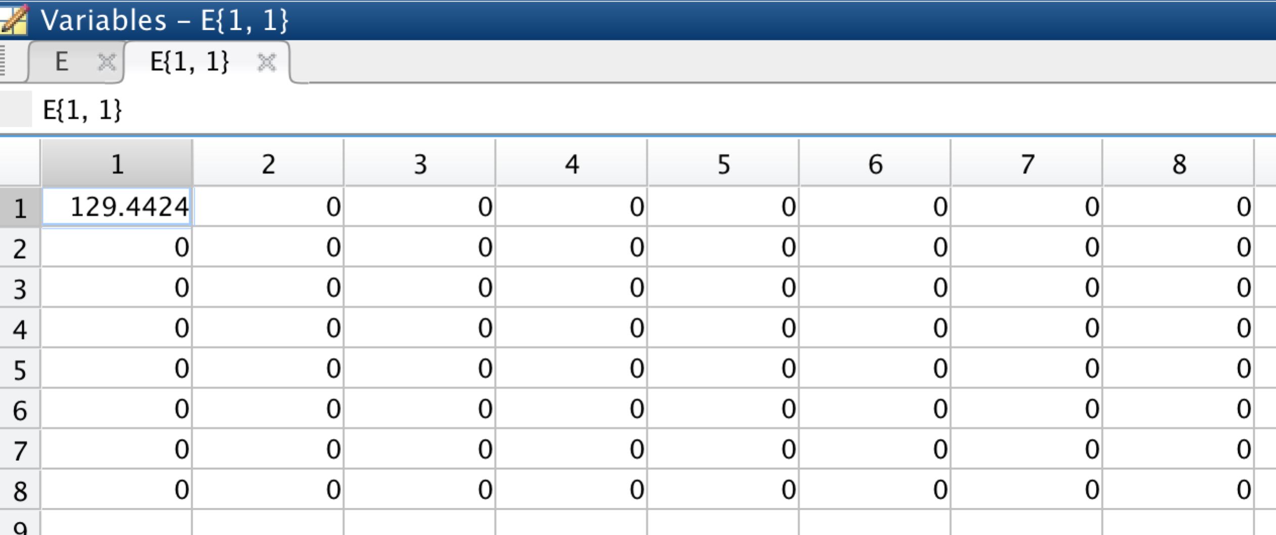

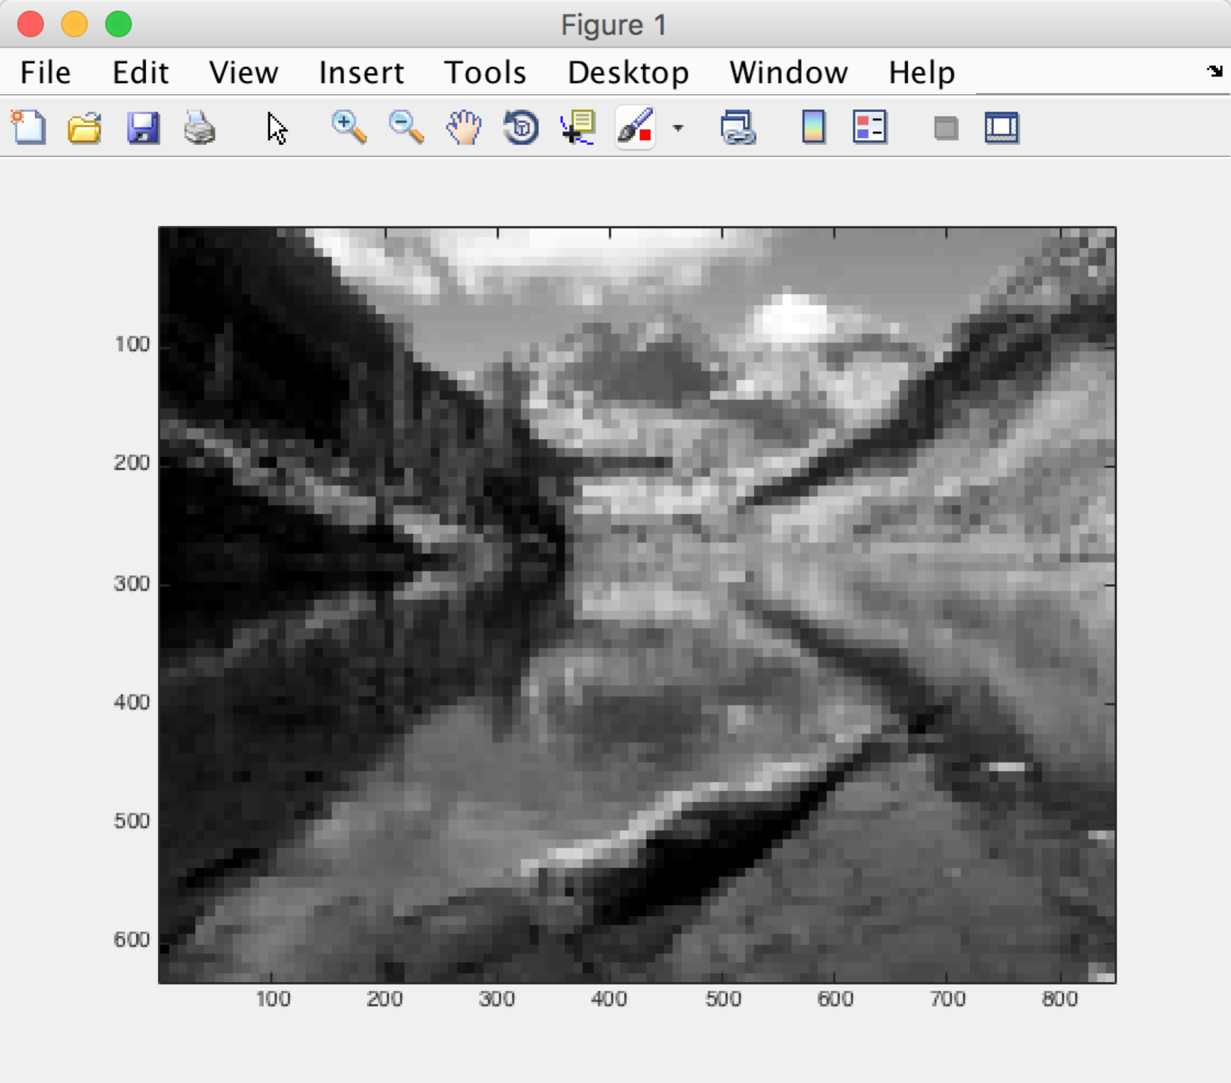

not clear

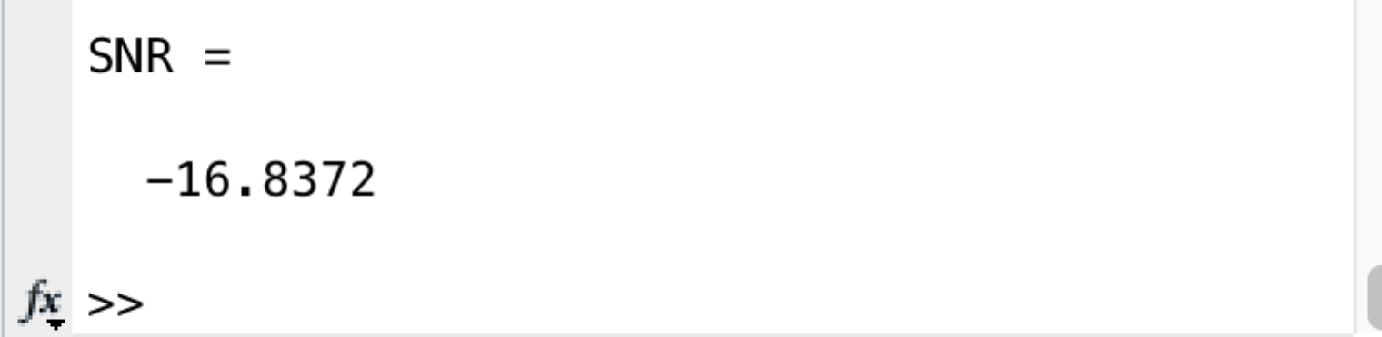

f)

the bitrates are 10/64,6/64,3/64,1/64

the SNRs are similar, they are -16.9138, -16.8980, -16.8765, -16.8372

the visual effect from b to e become worse and worse. That is reasonable because d has 10 elements while e only has one element. So the reconstruction effect is largely based on the elements.

So visual effect : G10>=G6>G3>>>>G1 (In my opinion).